**CS 553 Cloud Computing**

**Programming Assignment 2**

**Project Report**

**Dinesh Chowday Jasti (A20335710)**

**Jayanth Vangari (A20337867)**

**Sai Sravan Rachiraju (A20332891)**

The following are the most important aspects in this assignment:

* Creating a Virtual Cluster using AMAZON WEB SERVICES(AWS)
* Implementing Word count in JAVA
* Implementing Word count in HADOOP
* Implementing Word count in SWIFT
* Implementing Word count using MPI
* Implementing Sorting across 4 approaches (JAVA, HADOOP, SWIFT, MPI)
* Measuring the performance of the above

**Creating a Virtual Cluster using AMAZON WEB SERVICES(AWS):**

First we log in into the Amazon AWS service website (http://aws.amazon.com/) and we select EC2 from the network and services section. We select launch instance here. Then we configure our service to meet our requirements. We choose the AMI we need. Then we choose the instance type which can be micro, small, medium, large Xlarge, 2Xlarge, 4Xlarge or 8Xlarge. Then we configure the instance i.e we can choose the instance to be either spot instance or on Demand instance. We then add storage to our selected instance and configure the security group. We add TCP, UDP and ICMP protocols from the security group. We then create the instance. We access the instance by connecting to the instance by suing the public IP address of it and later on we can configure the settings of the AMI that we are using.

**Implementing Word count in JAVA:**

We implement a java program to count the occurrence of each word in a given input file of size 1MB and 1GB. We print the output into a file in the increasing order of the frequency of the word.

**Implementing Word count in HADOOP:**

After downloading and installing HADOOP and extracting its components and adding the library paths to the bash we connect to the AWS instance using ssh –i key (IP address). The word count application is implemented using HADOOP for 1MB on a single node and 10GB dataset on 16 nodes.

**Implementing Word count in SWIFT:**

The same word count application is implemented using SWIFT programming language for a 10GB dataset on 16 nodes.

**WORD COUNT IN MPI:**

The same word count application is implemented using MPI (Message Passing Interface) for a 10GB dataset on 16 nodes.

**PERFORMANCE CALCULATION:**

From the given data sets, all the three version of word count i.e. JAVA, HADOOP and SWIFT their performances are obtained on 1 node and 16 nodes. These are compared and performance graphs are drawn for them. The performance result of shared memory Word count is compared with the performance of swift word count and Hadoop word count which are implemented on 16 nodes. For each of the above separate graphs are drawn to show their performance.

**SORTING:**

Implementation and evaluation the performance of sorting for all the 4 versions of word count i.e. for JAVA, HADOOP, SWIFT, MPI on a 10GB dataset is done. This sorting performance includes reading, sorting and writing data to disks.

**Creating an instance in Amazon(AWS):**

* Log in into the Amazon AWS service website (<http://aws.amazon.com/>).
* Select EC2 from the network and services section.
* Select launch instance. Then configure the service and chose the best AMI to meet the requirements.
* Then choose the instance type which can be micro, small, medium, large Xlarge, 2Xlarge, 4Xlarge or 8Xlarge. For our assignment it is c3.large
* Then we configure the instance i.e we can choose the instance to be either spot instance or on Demand instance.
* Add storage to our selected instance.
* Configure the security group. We add TCP, UDP and ICMP protocols from the security group. We then create the instance. We access the instance by connecting to the instance by suing the public IP address of it and later on we can configure the settings of the AMI that we are using.

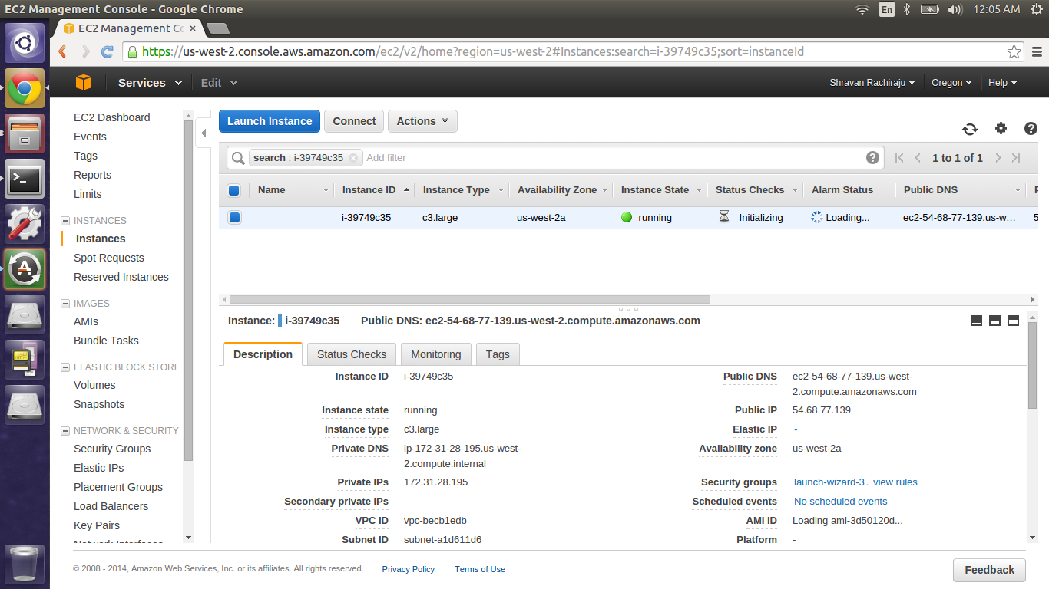

The above screen shot is of a c3.large instance.

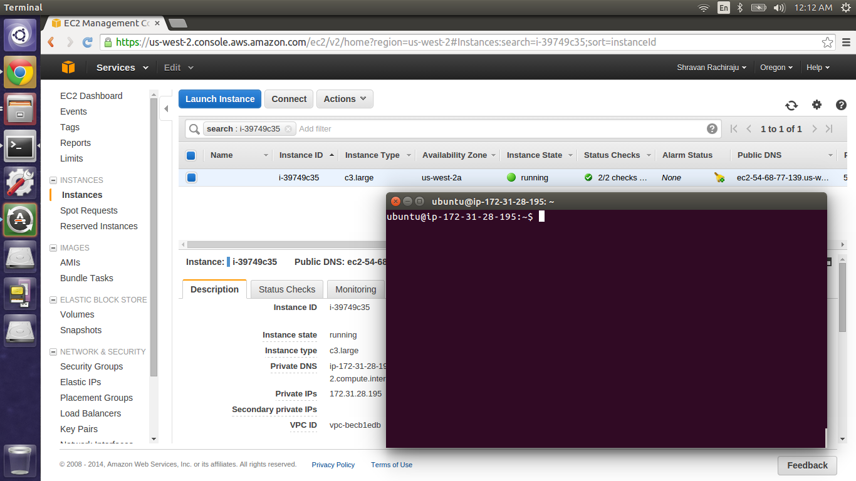

The above screen shot is of a connected instance via the Ubuntu terminal using the below commands:

chmod 400 keygiven( This is to change the permission to be read by owner. )

ssh –i key IP address

In our case we use ssh –i newkey.pem [Ubuntu@54.68.77.139](mailto:Ubuntu@54.68.77.139)

* After getting connected to the AMI we now have to install java on the virtual node.
* Install java by using sudo apt-get install openjdk-7-jreheadless.
* Install javac by using sudo apt-get install openjdk-7-jdk.
* Now update all the installed applications by using sudo apt-get update
* Now check the java version by using java –version.

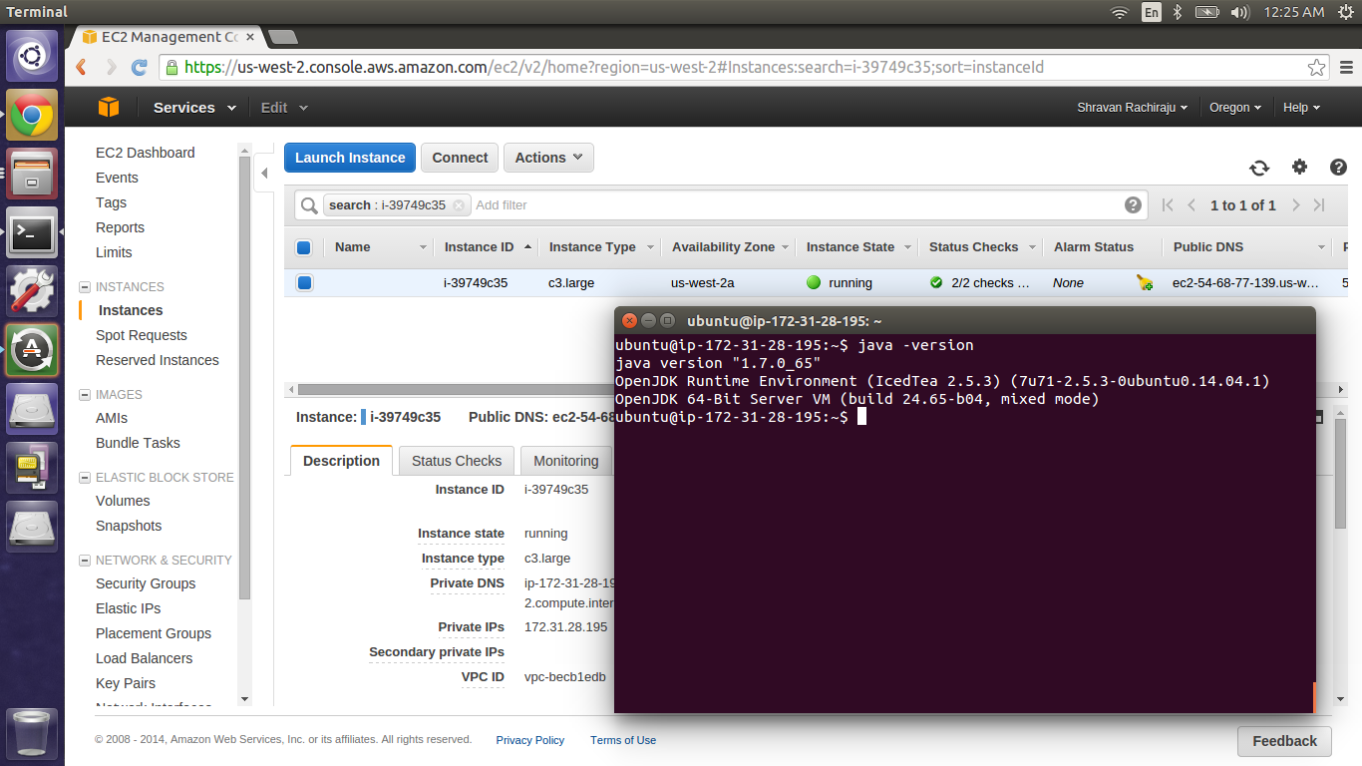

java –version is shown in the above screen shot

**WORD COUNT IN JAVA:**

**Configuration:**

VERSION : JAVA 1.7

INSTANCE TYPE : c3. Large UBUNTU

RAM : 3.75 GB

NO. OF CORES : 2 virtual cores

STORAGE : 32 GB

**METHODOLOGY:**

We take input of total size 10 gigabyte and count the number of lines in the file.

* On the basis of number of lines, we further split the data into equal no. of chunks.
* The file name of each chunk is fetched using a user defined function called *fileGeneration ()*. The *fileGeneration ()* has a dual functionality of fetching the file name and removing from the list once it is processed.
* In the function *count(),* each chunk is opened in the read mode and every line of chunk is read and every line is tokenized and then regular that it reads is stored into the map and it is tokenized into words with delimiters as *“ “* .
* A pattern match is run on each of these tokens to find the leading and trailing special symbols. Once these special symbols are determined the word is stored into the map *(m1)*. If the word has occurred for first time 1 is assigned as key for that particular word. The value of this key is incremented with subsequent occurrence of the token.
* The above mentioned point c and d, are executed under function called *run().* The threads are started and execute one file per thread. Numbers of threads are dependent on the number of chunks of a file.
* The point d is executed within the semaphore block to achieve the synchronization and hence avoid deadlocks in threads.
* Finally, we execute sorting. In sorting the hash map is converted into array list and this list is sorted using inbuilt sort function.
* The value of map is stored in the text file name *output.txt*.

**Outputs:**

**10 GB DATASET ON c3.large instance (Only Word Count with Frequency no sorting):**

|  |  |
| --- | --- |
| **Number of threads** | **Execution Time in Seconds** |
| 1 | 654.552 |
| 2 | 768.757 |
| 4 | 700.781 |
| 8 | 704.746 |

**EXPLANATION:**

Every thread is responsible for reading a file and processing it achieves the word count functionality

* Best performance was at thread 1

**10GB DATASET ON c3.large instance(Sorted word count without frequency based on the ASCII) :**

|  |  |
| --- | --- |
| **Number of threads** | **Execution Time in Seconds** |
| 1 | 2819.673 |
| 2 | 3503.585 |
| 4 | 2935.958 |
| 8 | 2927.552 |

**EXPLANATION:**

In a multithreaded process on a single processor, the processor can switch execution resources between threads, resulting in concurrent execution .

* Best performance was at thread 1. Thread 4 and 8 were very close in terms of execution time.

|  |  |  |  |
| --- | --- | --- | --- |
| **Number of threads** | **Execution Time in Seconds** | **Execution Time in Seconds for 1 Node** | **Speed Up** |
| 1 | 654.552 | 654.552 | 1 |
| 2 | 768.757 | 654.552 | 0.851442003 |
| 4 | 700.781 | 654.552 | 0.934032173 |
| 8 | 704.746 | 654.552 | 0.928777176 |

**Screens Shots Word Count with Frequency no sorting :**

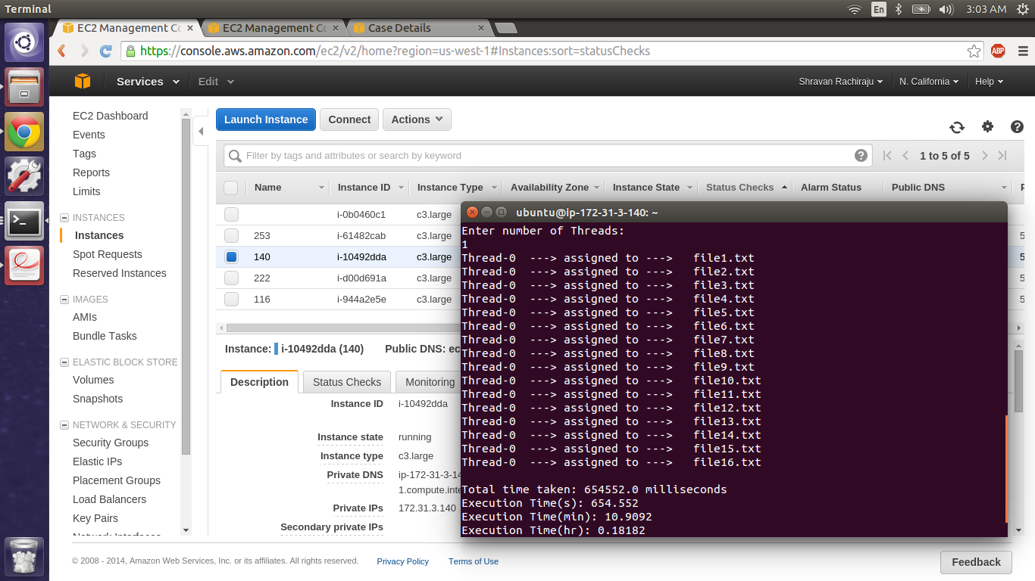

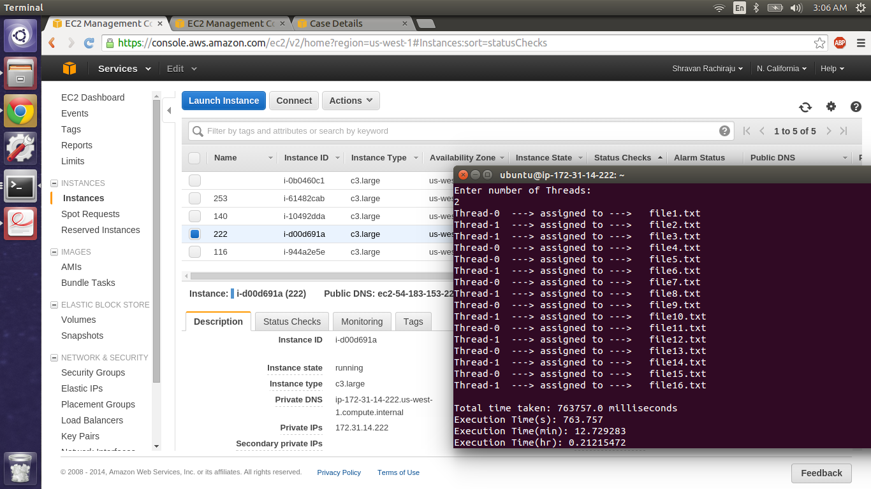

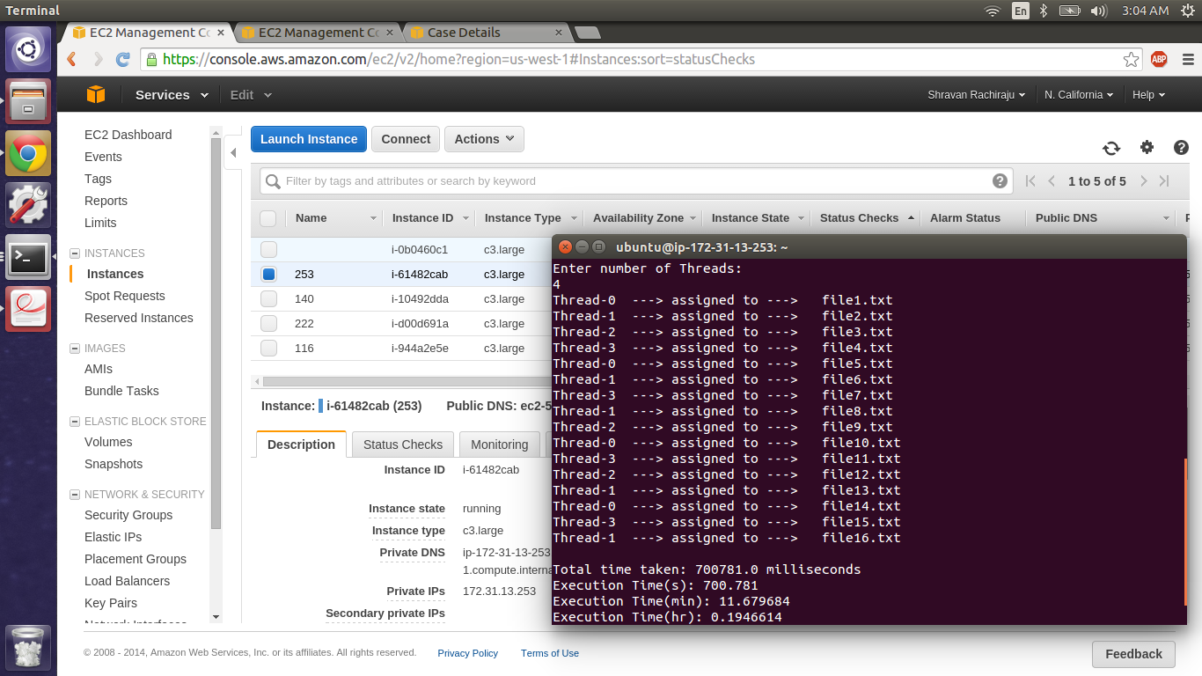

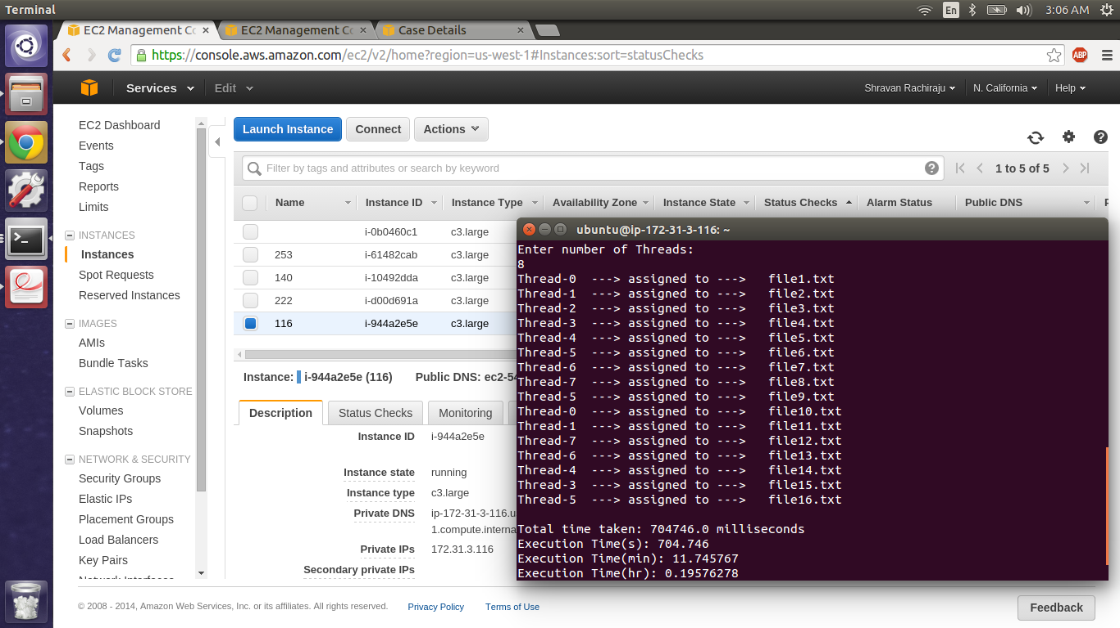

**Running Instance:**

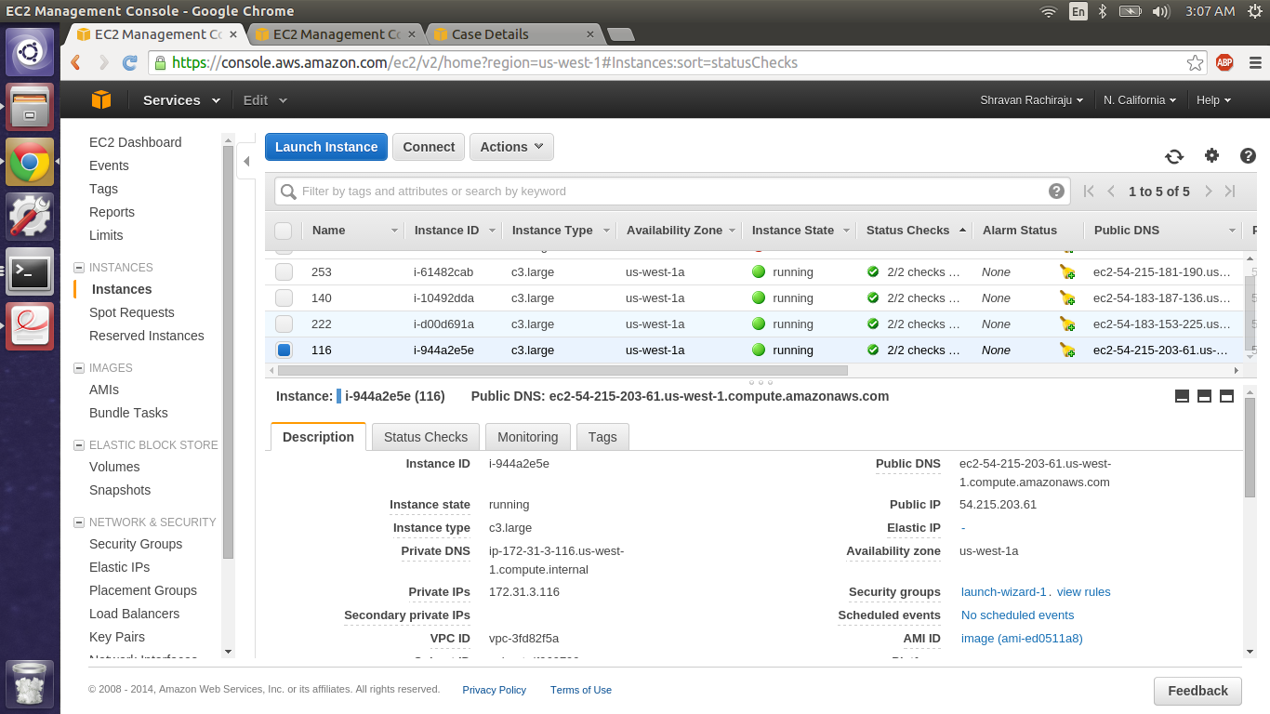

**Screen Shots Sorted word count without frequency based on the ASCII:**

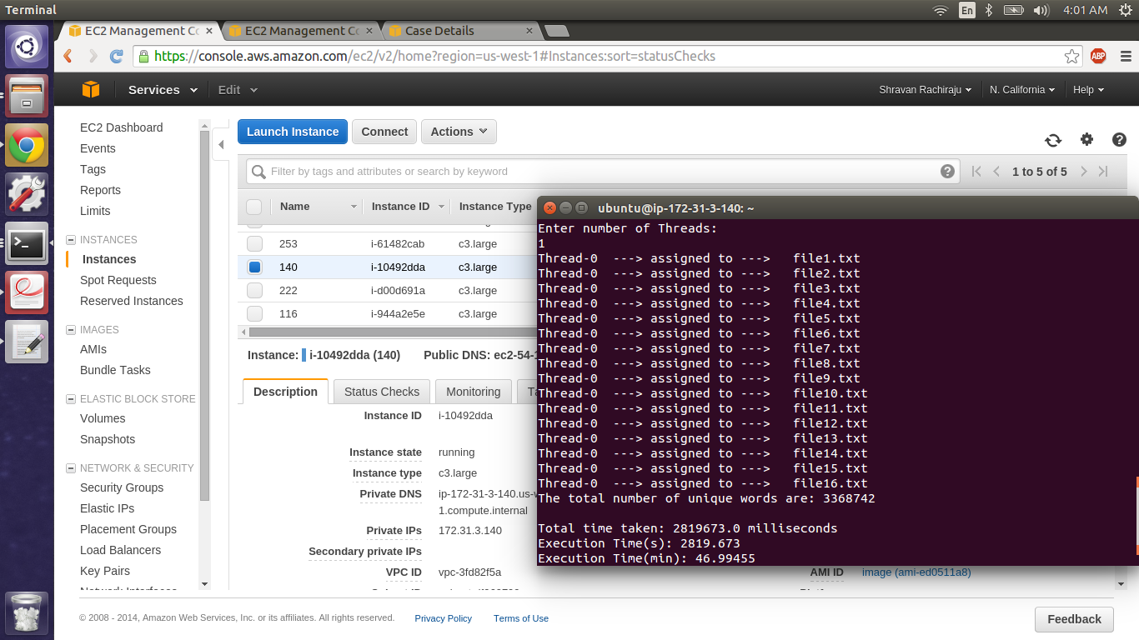

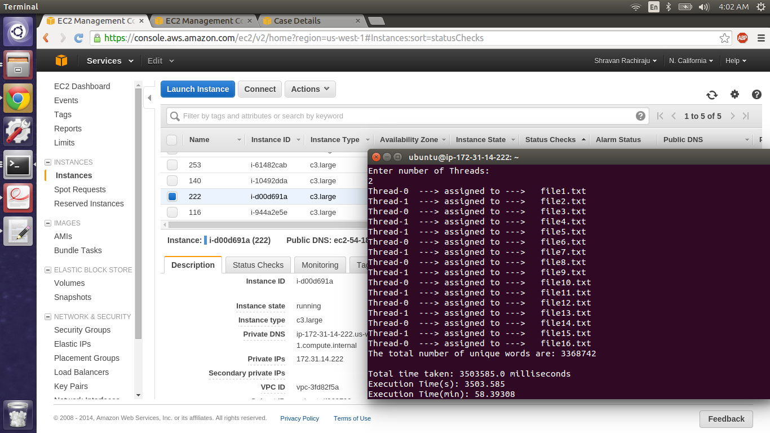

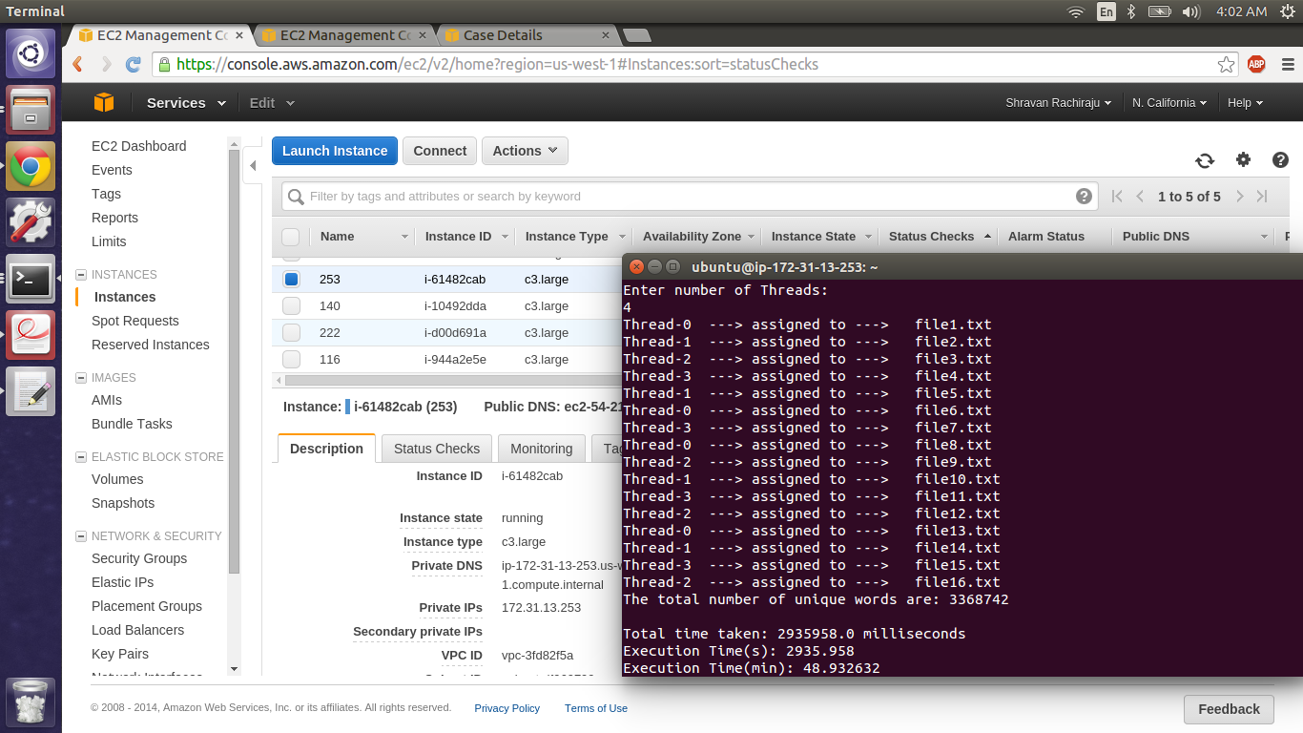

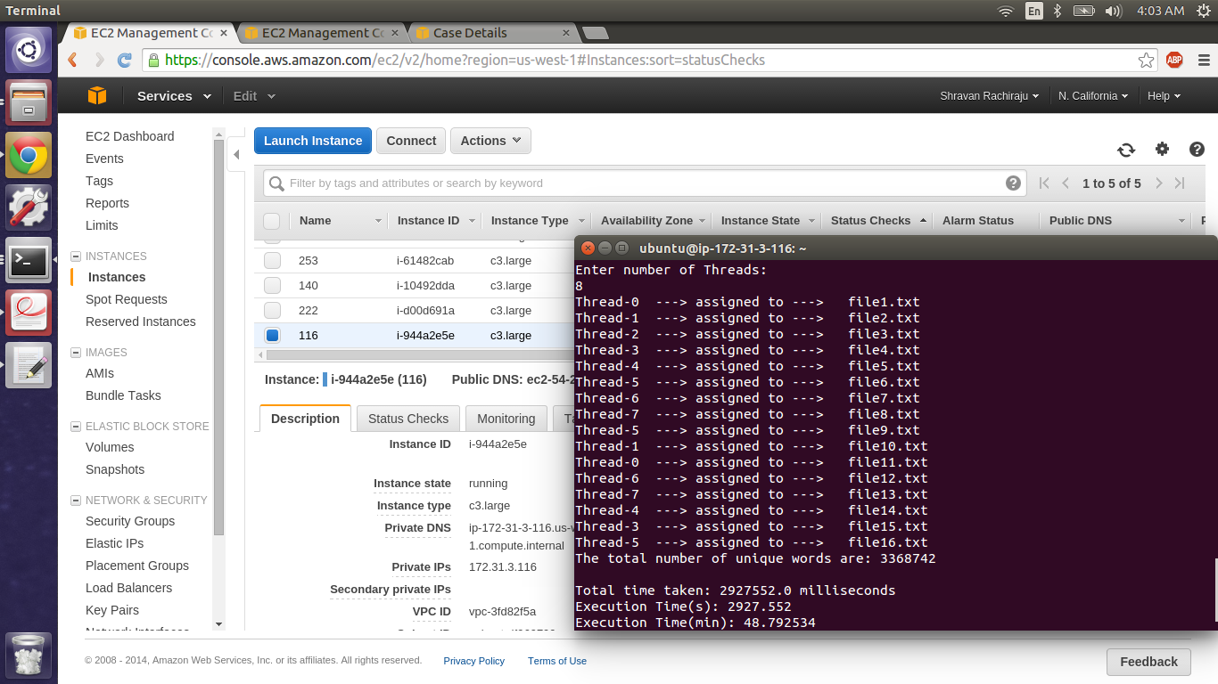

**Best Performance:**

Normal Word Count with Frequency no sorting: 1 Thread

Sorting Sorted word count without frequency based on the ASCII: 1 Thread

**Setting Up a Virtual Cluster of 16 Nodes + 1 Master:**

**Creating an instance in Amazon(AWS):**

* Log in into the Amazon AWS service website (<http://aws.amazon.com/>).
* Select EC2 from the network and services section.
* Select launch instance. Then configure the service and chose the best AMI to meet the requirements.
* Then choose the instance type which can be micro, small, medium, large Xlarge, 2Xlarge, 4Xlarge or 8Xlarge. For our assignment it is c3.large
* Then we configure the instance i.e we can choose the instance to be either spot instance or on Demand instance.
* Add storage to our selected instance.
* Configure the security group. We add TCP, UDP and ICMP protocols from the security group. We then create the instance. We access the instance by connecting to the instance by suing the public IP address of it and later on we can configure the settings of the AMI that we are using.

**To Connect to the Node:**

chmod 400 keygiven( This is to change the permission to be read by owner. )

ssh –i key IP address

In our case we use:

1. chmod 400 newkey.pem
2. ssh –i newkey.pem Ubuntu@54.69.130.130

After the connection is established:

* After getting connected to the AMI we now have to install java on the virtual node.
* Install java by using sudo apt-get install openjdk-7-jreheadless.
* Install javac by using sudo apt-get install openjdk-7-jdk.
* Now update all the installed applications by using sudo apt-get update
* Now check the java version by using java –version.
* Now right click the instance we created and select “create image” option. This will create an image for what all we did till now and reflect the same in the other instances.
* Go to the images tab in the left panel of the AWS webpage and select AMI images. You will see the name of the image we just created. Select that and launch the other 16 nodes.

**Screen Shots of 17 nodes (1 Master and the other 16 are slaves):**

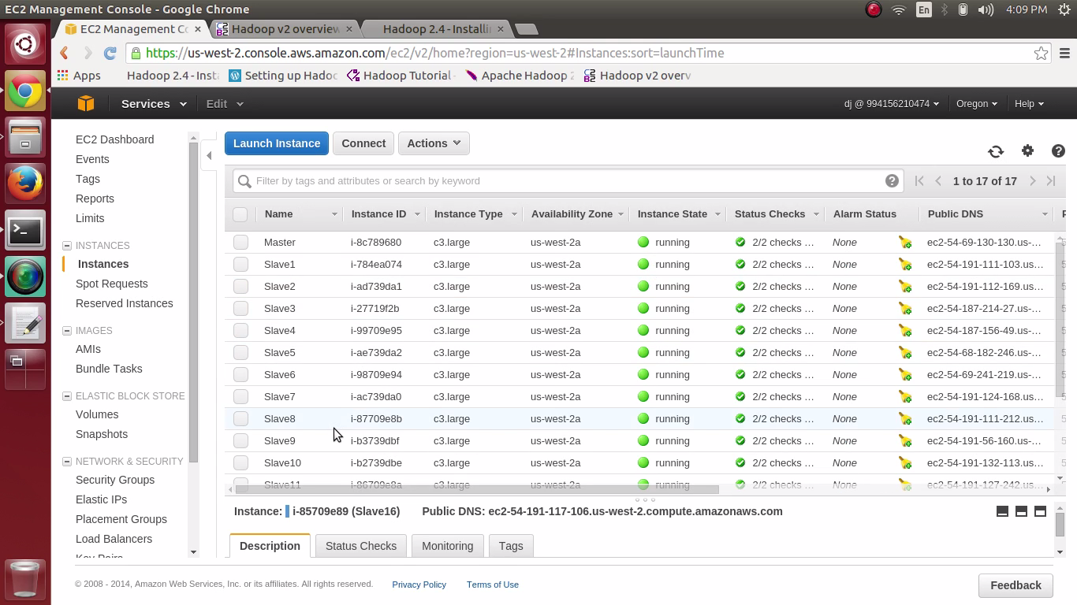

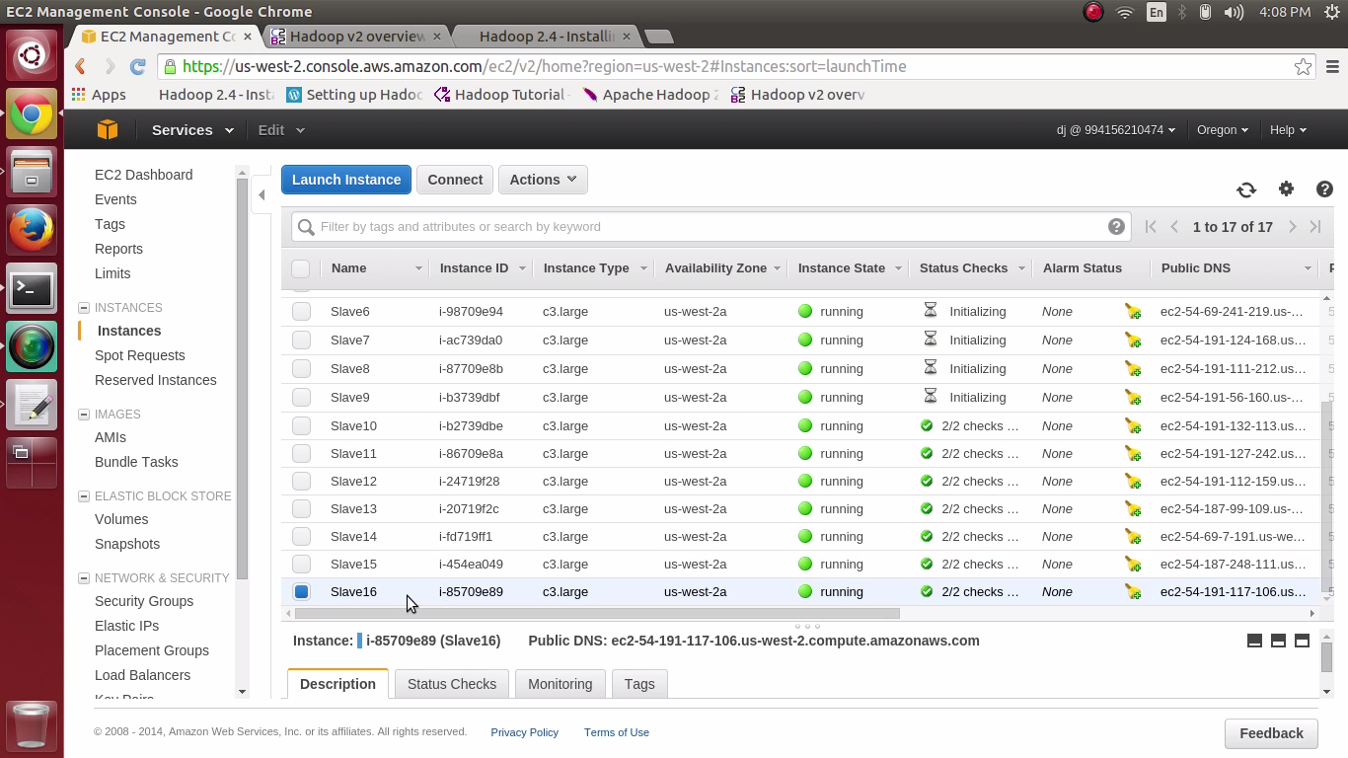

**Hadoop:**

**Installation:**

**Creating an instance in Amazon(AWS):**

* Log in into the Amazon AWS service website (<http://aws.amazon.com/>).
* Select EC2 from the network and services section.
* Select launch instance. Then configure the service and chose the best AMI to meet the requirements.
* Then choose the instance type which can be micro, small, medium, large Xlarge, 2Xlarge, 4Xlarge or 8Xlarge. For our assignment it is c3.large
* Then we configure the instance i.e we can choose the instance to be either spot instance or on Demand instance.
* Add storage to our selected instance.
* Configure the security group. We add TCP, UDP and ICMP protocols from the security group. We then create the instance. We access the instance by connecting to the instance by suing the public IP address of it and later on we can configure the settings of the AMI that we are using.

**To Connect to the Node:**

chmod 400 keygiven( This is to change the permission to be read by owner. )

ssh –i key IP address

In our case we use:

1. chmod 400 dj_key.pem
2. ssh –i dj_key.pem Ubuntu@54.69.130.130

After the connection is established:

* After getting connected to the AMI we now have to install java on the virtual node.
* Hadoop Frame Work is written in java, so we need to install java on all the nodes.
* Install java by using sudo apt-get install openjdk-7-jreheadless.
* Install javac by using sudo apt-get install openjdk-7-jdk.
* Now update all the installed applications by using sudo apt-get update
* Now check the java version by using java –version.

**To Install Hadoop:**

* In the terminal do a wget <http://mirrors.sonic.net/apache/hadoop/common/hadoop-2.4.1/hadoop-2.4.1.tar.gz>
* Unzip it Using “tar xvzf hadoop-2.5.1.tar.gz”
* Create a folder installs in hadoop and then move the contents into this folder.

The following files will have to be modified to complete the Hadoop setup:

* ~/.bashrc
* / conf /hadoop-env.sh
* / conf /core-site.xml
* / conf /yarn-site.xml
* / conf /hdfs-site.xml
* / conf /mapred-site.xml.template

1. ~/.bashrc:

#HADOOP VARIABLES START

export JAVA_HOME=/usr/lib/jvm/java-7-openjdk-amd64

export HADOOP_INSTALL=/usr/ubuntu/installs/hadoop

export PATH=$PATH:$HADOOP_INSTALL/bin

export PATH=$PATH:$HADOOP_INSTALL/sbin

export HADOOP_MAPRED_HOME=$HADOOP_INSTALL

export HADOOP_COMMON_HOME=$HADOOP_INSTALL

export HADOOP_HDFS_HOME=$HADOOP_INSTALL

export YARN_HOME=$HADOOP_INSTALL

export HADOOP_COMMON_LIB_NATIVE_DIR=$HADOOP_INSTALL/lib/native

export HADOOP_OPTS="-Djava.library.path=$HADOOP_INSTALL/lib"

eval ($ssh-agent);

ssh-add/home/ubuntu/dj_key.pem

#HADOOP VARIABLES END

Reboot the connection now for the changes to be reflected.

1. / conf /hadoop-env.sh:

This is to set the JAVA Path by modifying **hadoop-env.sh** file

export JAVA_HOME=/usr/lib/jvm/java-7-openjdk-amd64

1. / conf /core-site.xml:

The **/usr/local/hadoop/etc/hadoop/core-site.xml** file contains configuration properties that Hadoop uses when starting up. This file can be used to override the default settings that Hadoop starts with.

<configuration>

  <property>

    <name>fs.default.name</name>

    <value>hdfs://<172.31.22.90>:9000</value>

  </property>

  <property>

    <name>hadoop.tmp.dir</name>

    <value>/home/ubuntu/installs/hadoop/hadoop_tmp/tmp</value>

  </property>

</configuration>

1. / conf /yarn-site.xml:

<configuration>

<property>

<name>yarn.nodemanager.aux-services</name>

<value>mapreduce_shuffle</value>

</property>

<property>

<name>yarn.nodemanager.aux-services.mapreduce.shuffle.class</name>

<value>org.apache.hadoop.mapred.ShuffleHandler</value>

</property>

<property>

<name>yarn.resourcemanager.resource-tracker.address</name>

<value><172.31.22.90>:8025</value>

</property>

<property>

<name>yarn.resourcemanager.scheduler.address</name>

<value><172.31.22.90>:8030</value>

</property>

<property>

<name>yarn.resourcemanager.address</name>

<value><172.31.22.90>:8040</value>

</property>

</configuration>

1. / conf /hdfs-site.xml:

  <configuration>

    <property>

      <name>dfs.replication</name>

     <value>**16**</value>

    </property>

    <property>

     <name>dfs.permissions</name>

     <value>false</value>

   </property>

  </configuration>

1. /conf /mapred-site.xml:

By default, the /usr/local/hadoop/etc/hadoop/ contains the /usr/local/hadoop/etc/hadoop/mapred-site.xml.template file which has to be renamed/copied with the name mapred-site.xml:

“cp /usr/local/hadoop/etc/hadoop/mapred-site.xml.template/usr/local/hadoop/etc/hadoop/mapred-site.xml”

The **mapred-site.xml** file is used to specify which framework is being used for MapReduce. We need to enter the following content in between the <configuration></configuration> tag:

<configuration>

  <property>

   <name>mapreduce.framework.name</name>

    <value>yarn</value>

 </property>

</configuration>

Create an IMAGE for all this so that it can be reflected in all the nodes. This would be the basic configuration for hadoop for 1 node setup. For 16 node setup we have to edit 2 more configuration files the conf/hosts, conf/slaves on the **MASTER NODE ONLY**.

Master and Slave Nodes Connected:

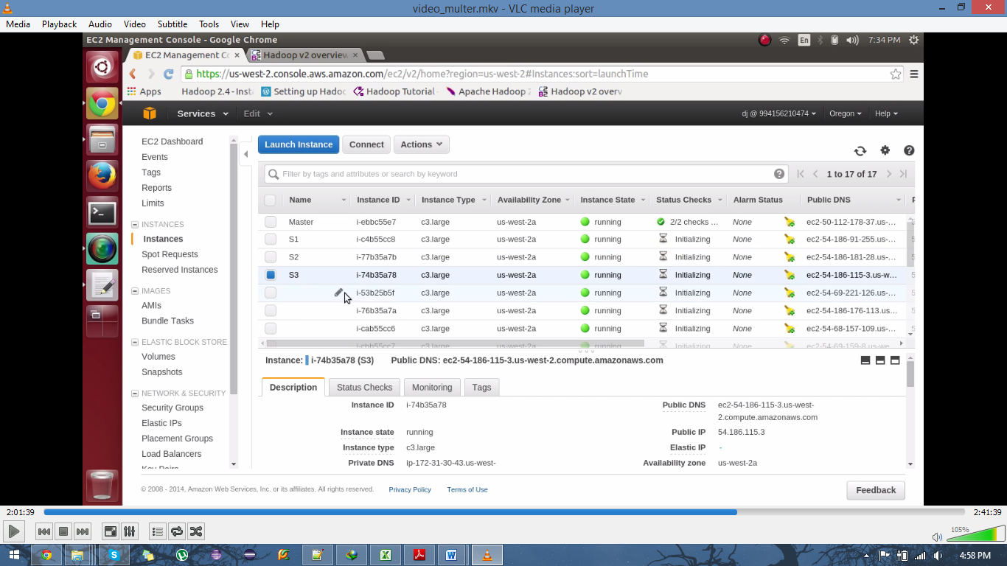

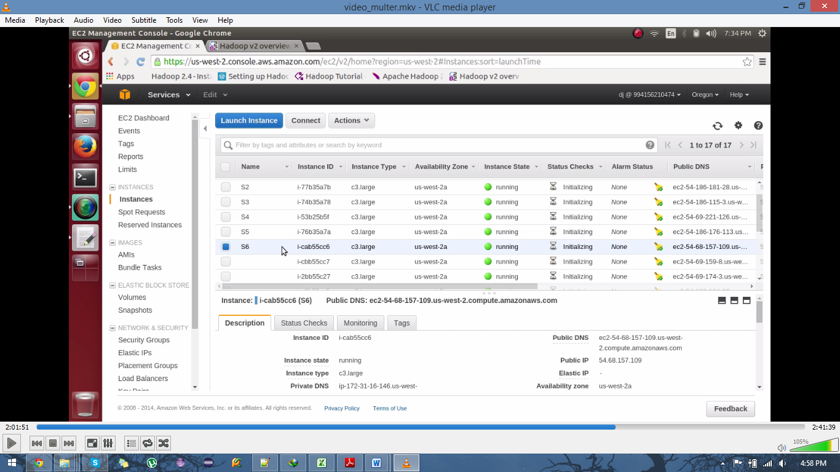

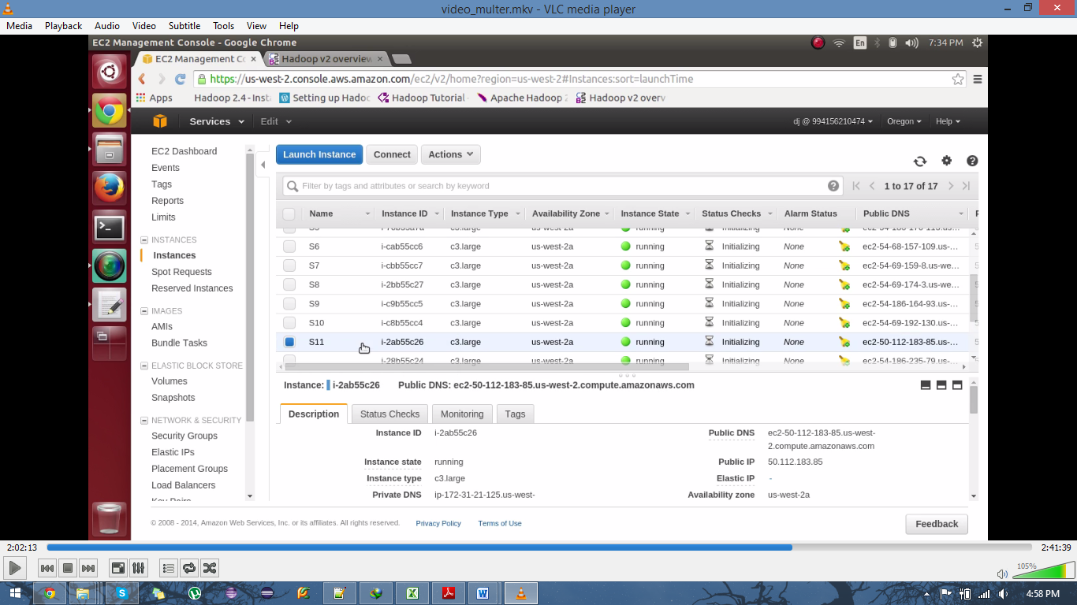

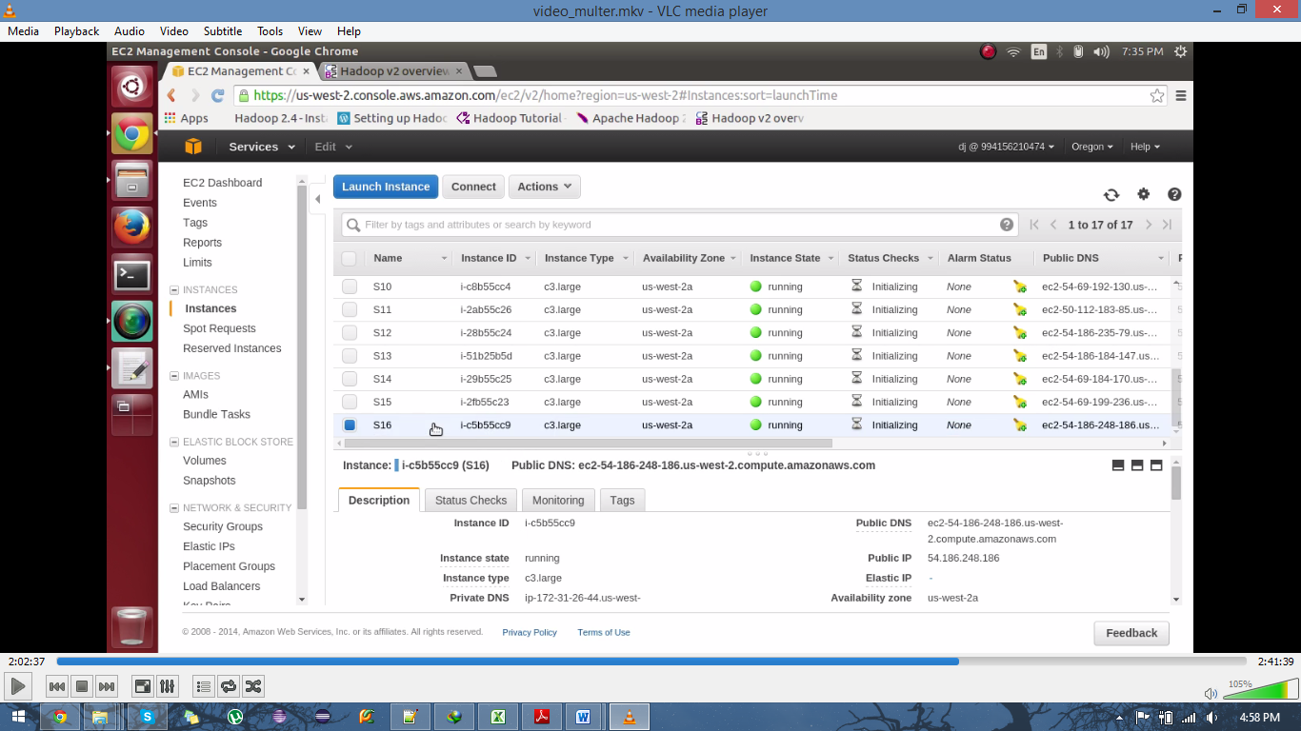

1. / conf /slaves:

Add all the IP address to the slaves file

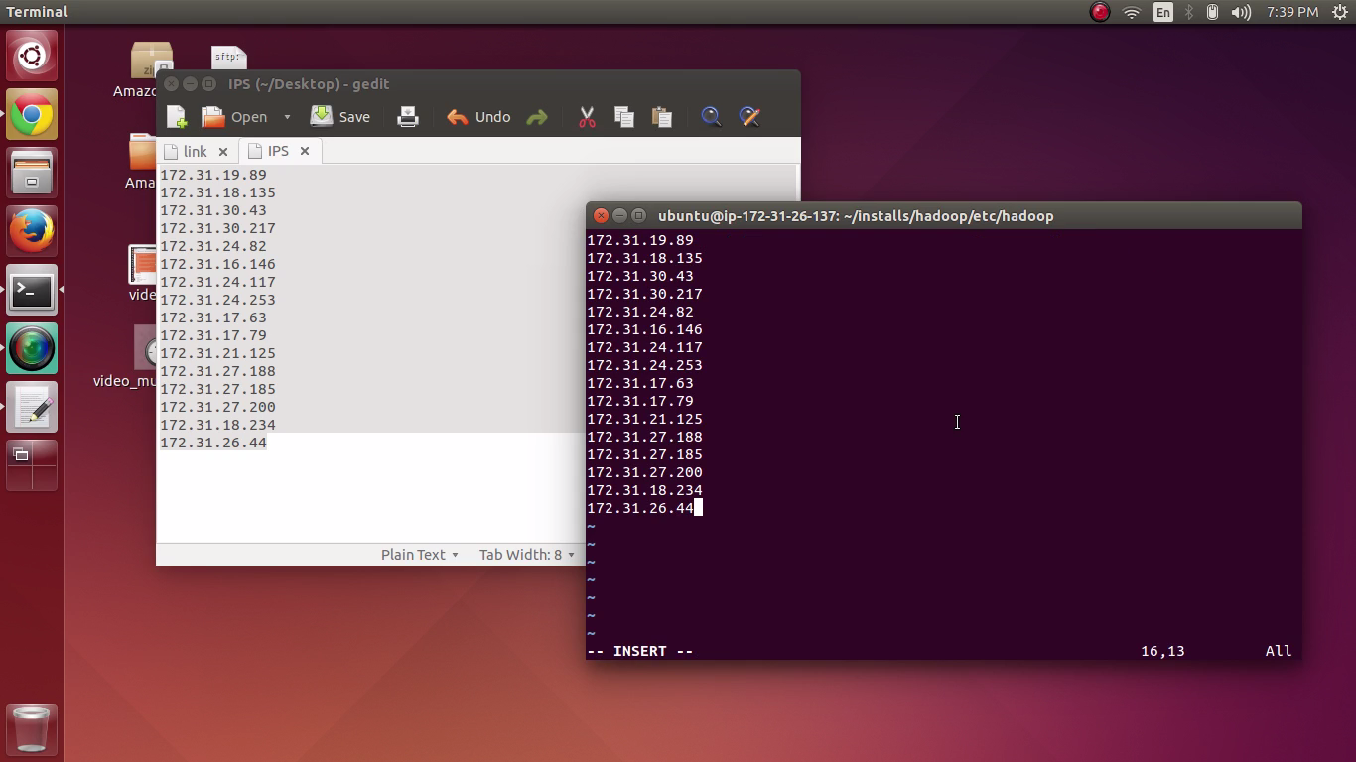

1. conf/hosts:

Add all the IP’s of the the slaves in the file including the master IP.

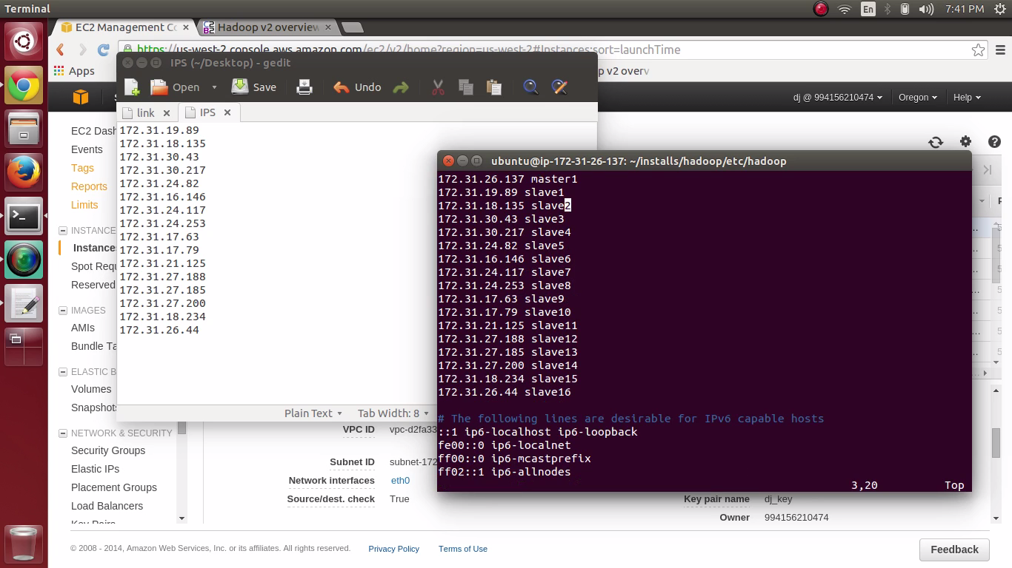

1. The namenode will run only on the master in our test setup and is started by executing the following command:

* $<HADOOP_HOME>/sbin/hadoop-daemon.sh start namenode

1. Start the datanodes which will run on both the slave nodes:

* $<HADOOP_HOME>/hadoop-daemons.sh start datanode

1. The resource manager process will run only on the master and is started using the following command:

* $<HADOOP_HOME>/yarn-daemon.sh start resourcemanager

1. The node manager process runs on each of the slave nodes and is started using this command.:

* $<HADOOP_HOME>/yarn-daemons.sh start nodemanager

1. The job history server process runs on the master node and is started using the following command:

* $<HADOOP_HOME>/mr-jobhistory-daemon.sh start historyserver

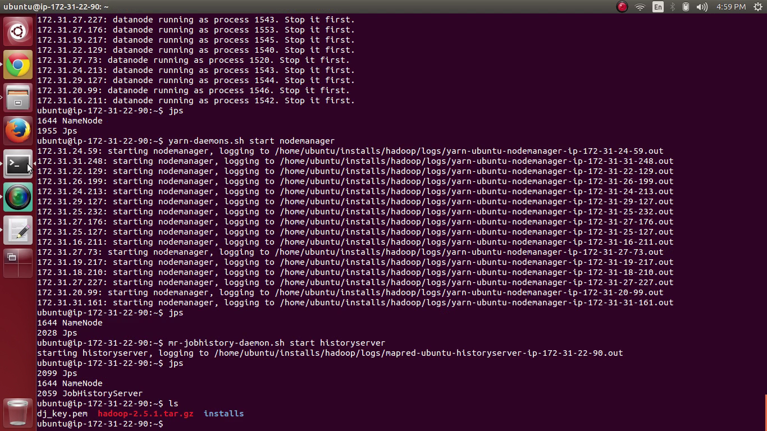

To Check if the nodes are connected we login into another node and do jps:

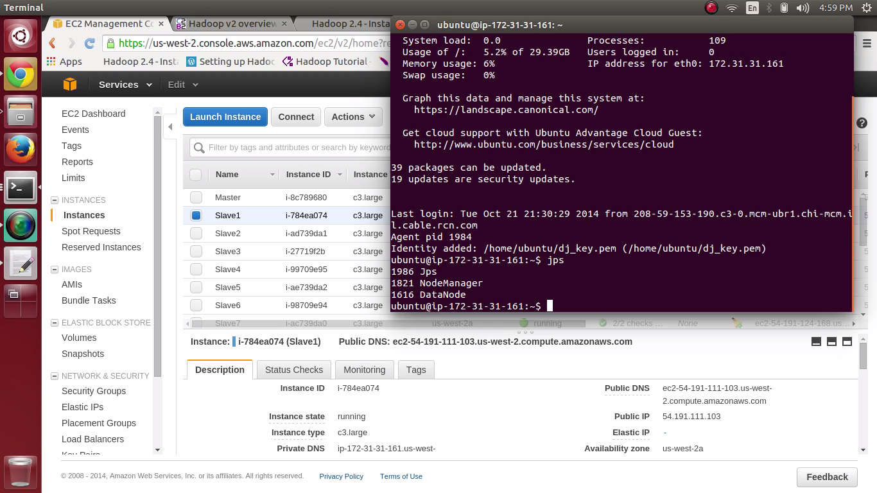

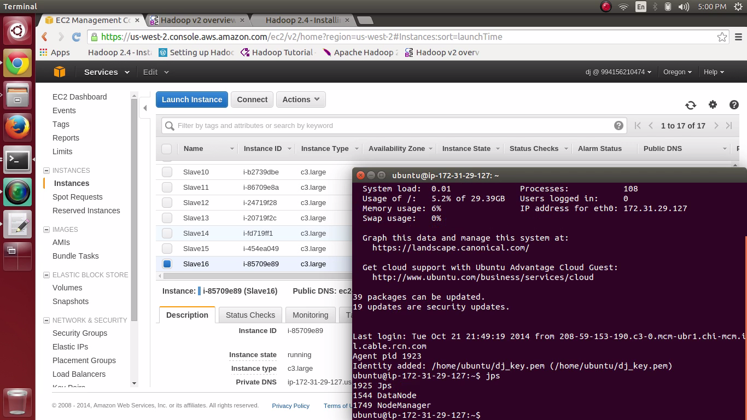

Screen Shots of the Configuration FILES:

~/.bashrc:

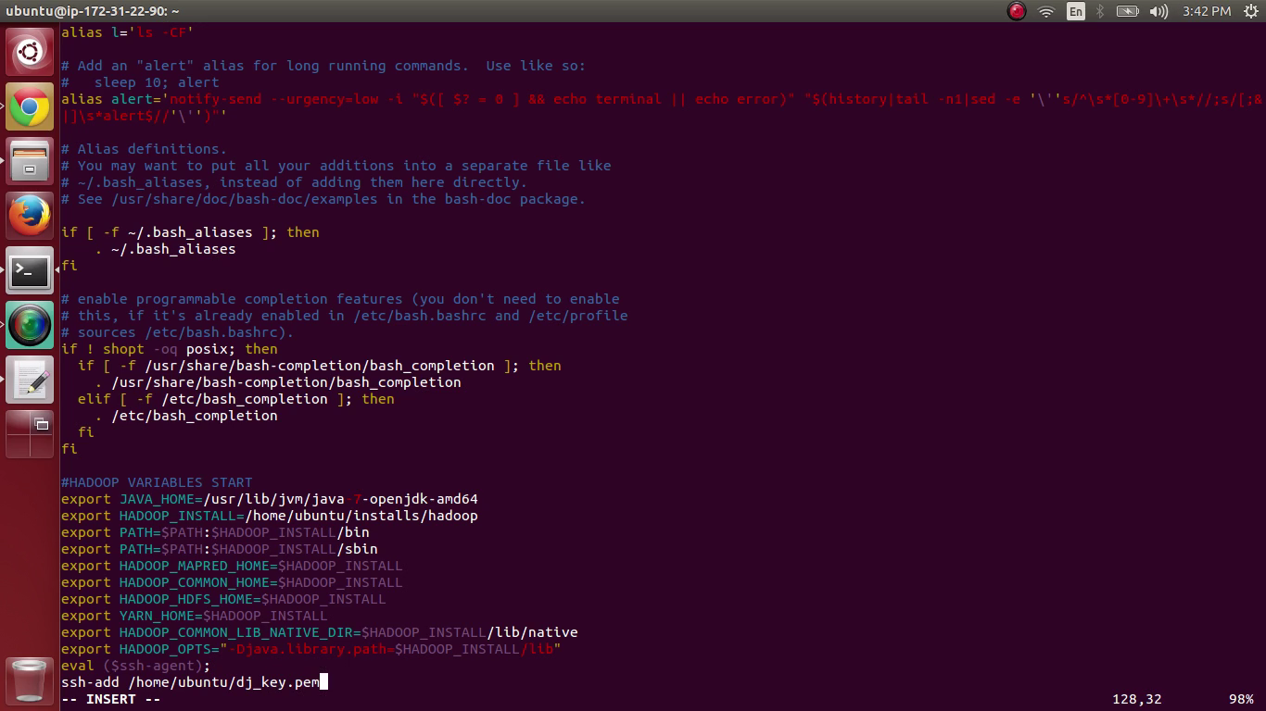

conf /hadoop-env.sh

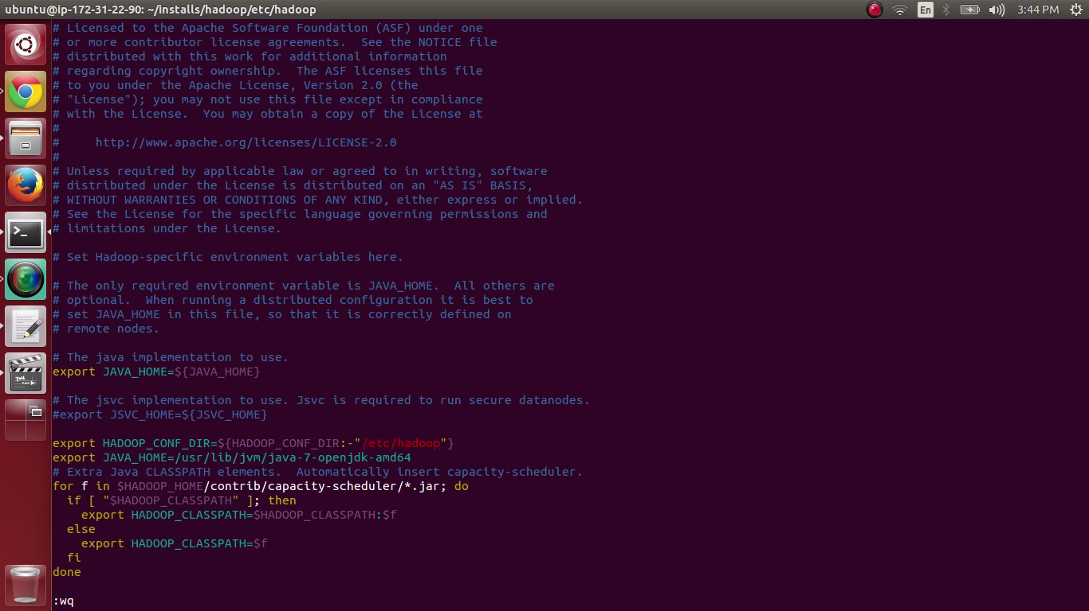

/ conf /core-site.xml:

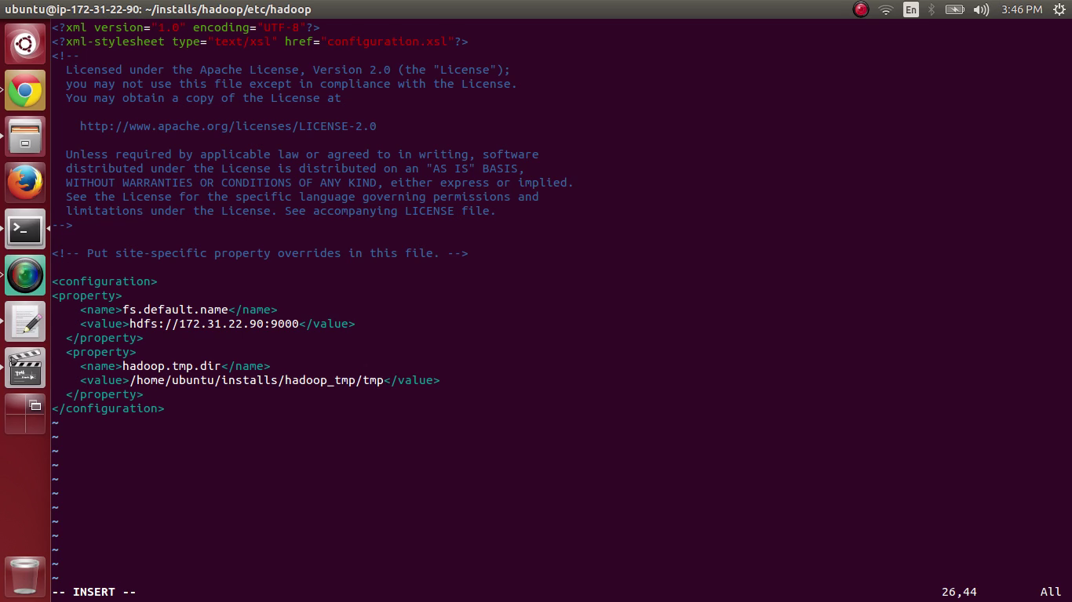

/ conf /yarn-site.xml:

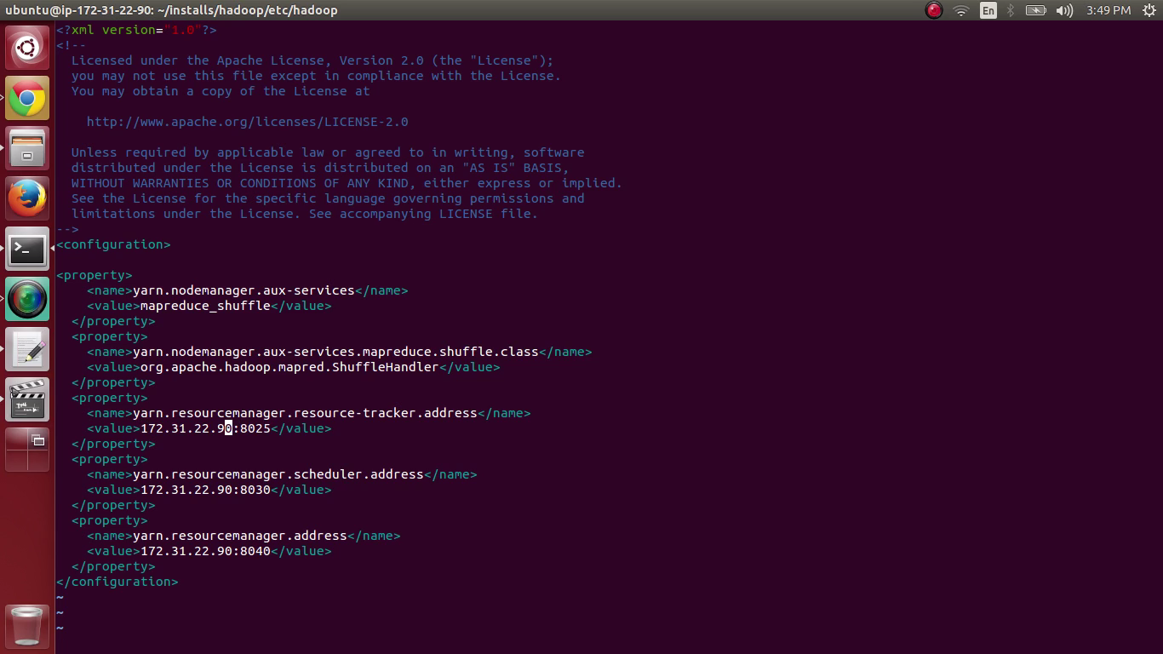

/ conf /hdfs-site.xml:

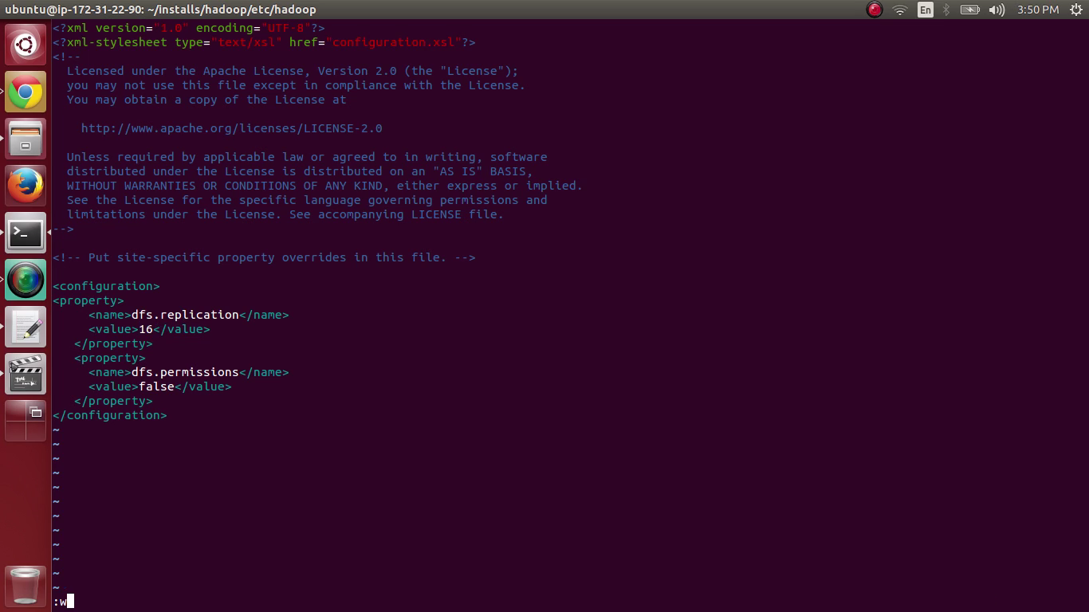

/conf /mapred-site.xml :

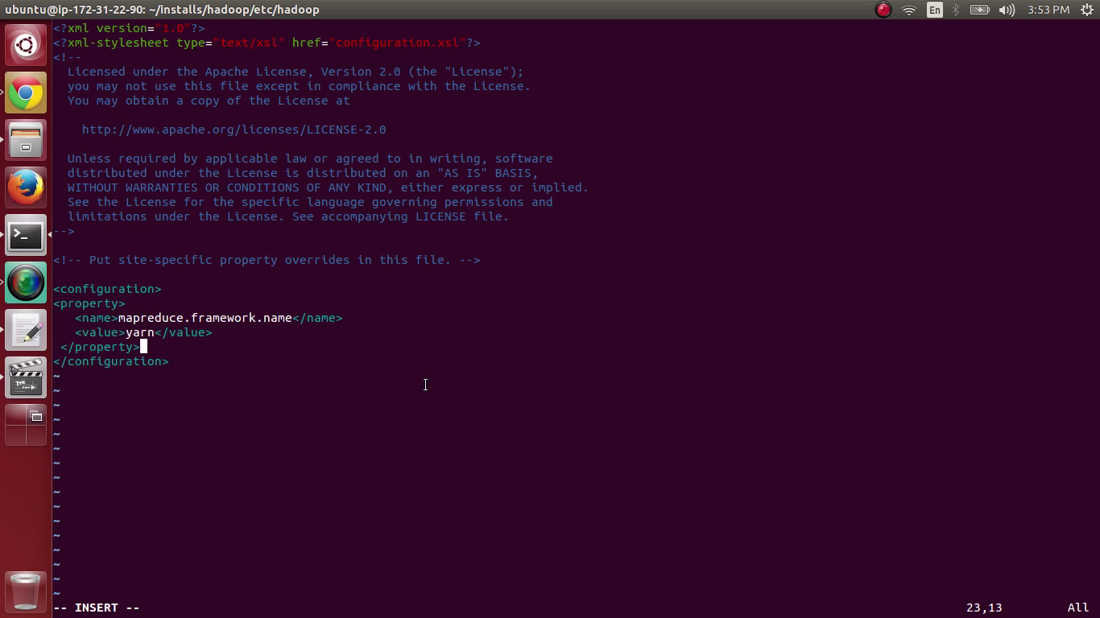

Connecting to Data Nodes:

Screen Shots:

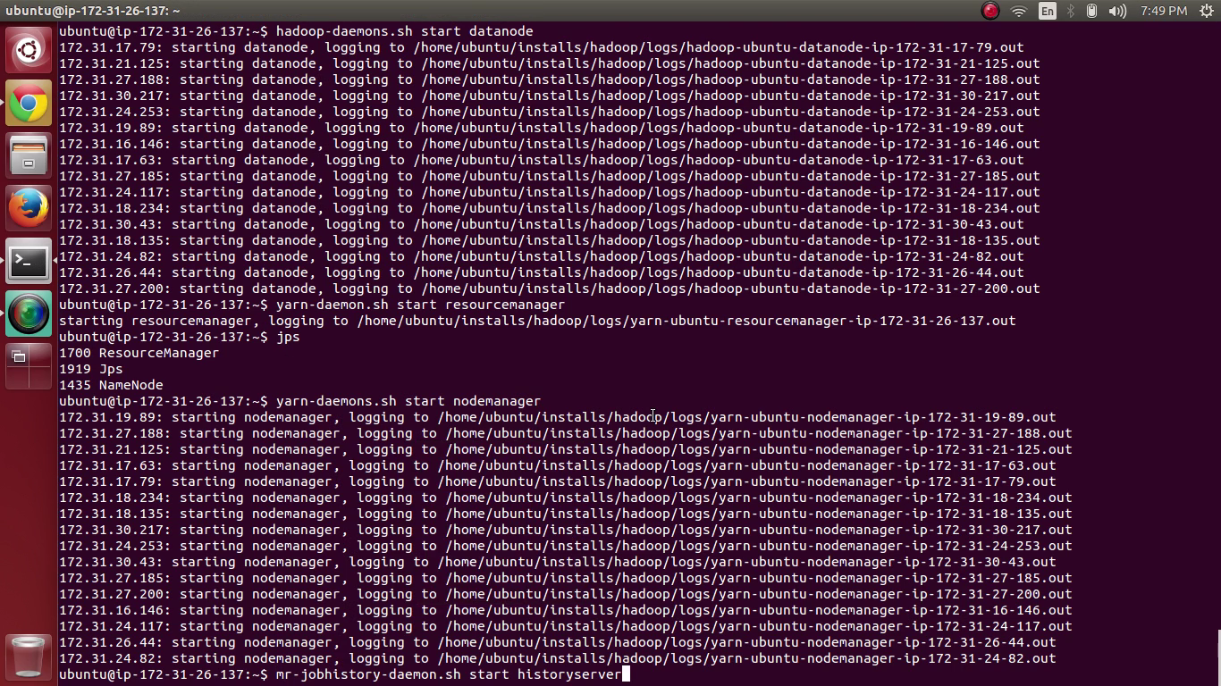

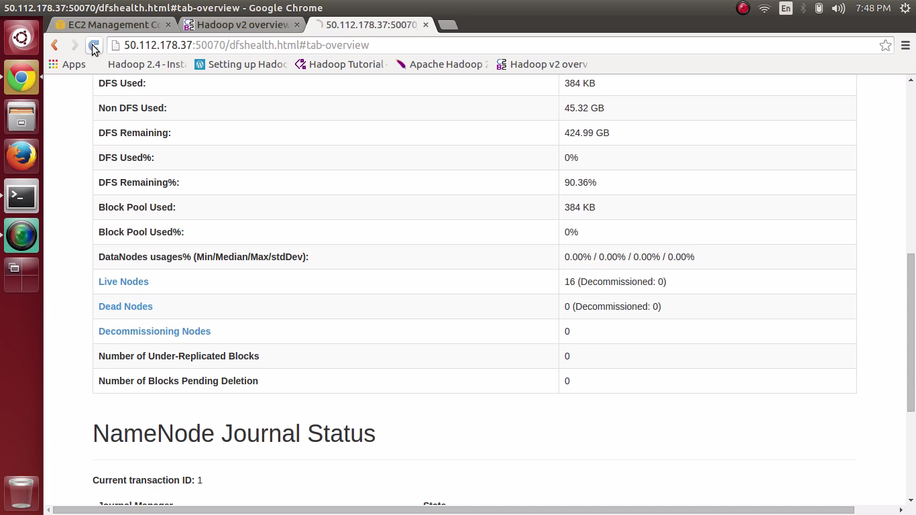

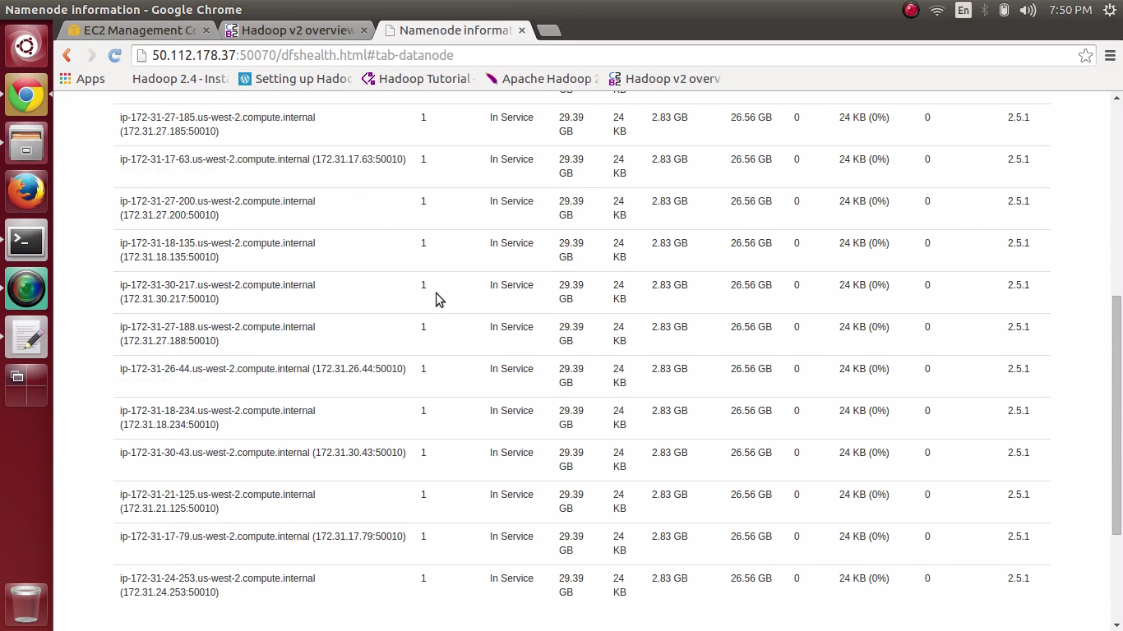

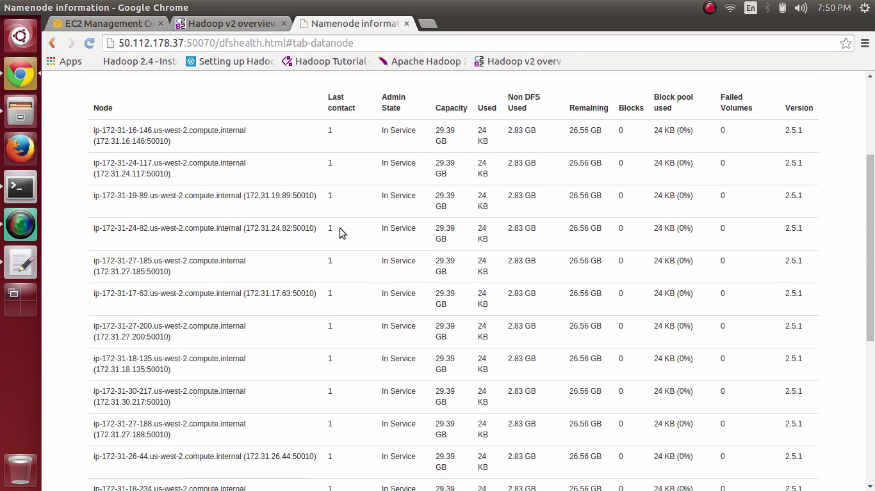

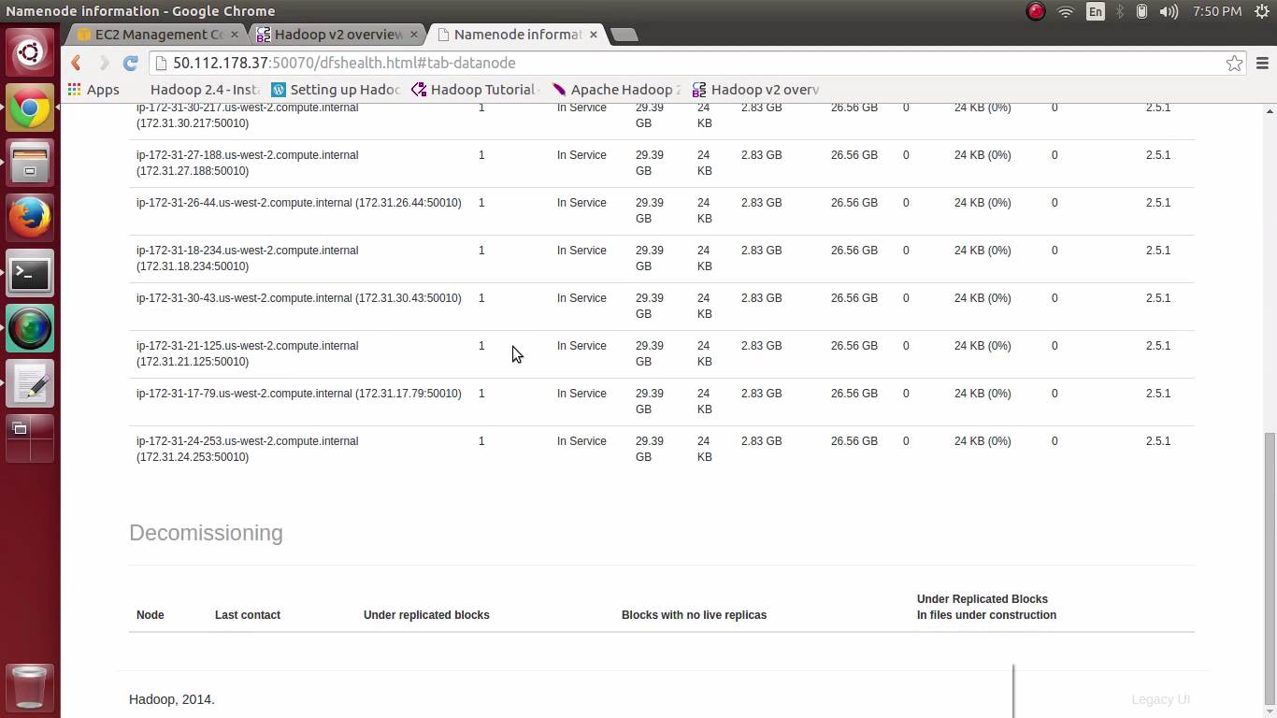

**Word Count in Hadoop:**

**SYSTEM CONFIGURATION:**

VERSION : Hadoop 1.2.1

INSTANCE TYPE : c3. Large UBUNTU

RAM : 3.75 GB

NO. OF CORES : 2 virtual cores

STORAGE : 32 GB

**Methodology:**

1. HADOOP framework is written in java.
2. Install java latest version (1.7) and check version by using java –version command.
3. Next is to create and to setup SSH certificates and install HADOOP.
4. Hadoop WordCount Map Reduce: MapReduce programs are designed to compute large volumes of data in a parallel fashion i.e. 10GB input. This requires dividing the workload across a two or single nodes.
5. List Processing: MapReduce programs transform lists of input data elements into lists of output data elements. A MapReduce program will do this twice, using two different list processing idioms: map, and reduce.
6. Mapping List: In the first phase called mapping, a list of data elements are provided, one at a time, to a function called the Mapper, which transforms each element individually to an output data element. As an example of the utility of map: We have a code to remove all the special characters (symbols) form the beginning and end of the word. We are not modifying the input string here: we are returning a new string that will form part of a new output list.
7. Reducing List: Reducing aggregate values together. A reducer function receives an iterator of input values from an input list. It then combines these values together, returning a single output value.
8. Now set up the configuration files and format the HADOOP file system and start HADOOP.
9. We have to access the output from the HDFS. This can be done using get command.
10. The output files stored are titled as wordcount-HADOOP.txt

**Outputs:**

**10 GB DATASET ON c3.large instance (Only Word Count with Frequency no sorting):**

|  |  |
| --- | --- |
| Nodes | Execution time in seconds |
| 1 | 2950 |
| 2 | 1338 |
| 4 | 850.8 |
| 6 | 625.8 |
| 8 | 498 |
| 16 | 327.6 |

**EXPLANATION:**

1. The above graph is clearly shows that as number of nodes increases the execution time decreases.

**Screen Shots for setting up and running 2,4,6, 8 and 16 nodes:**

2 Nodes: 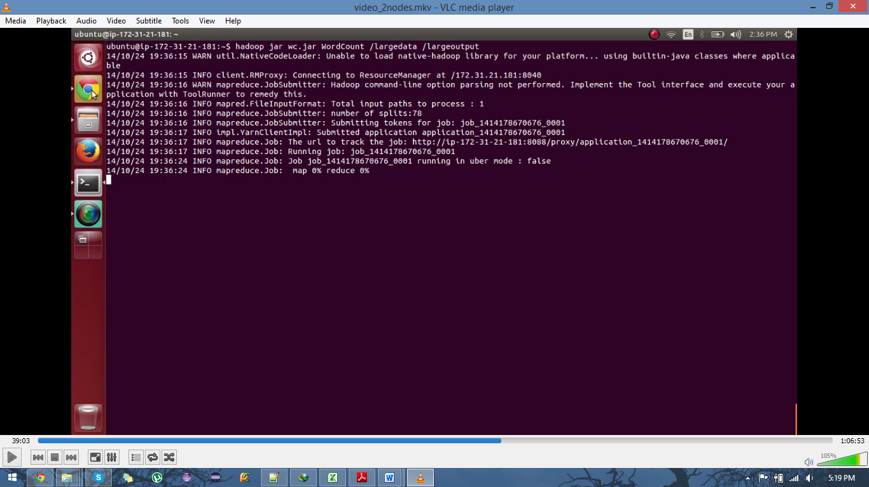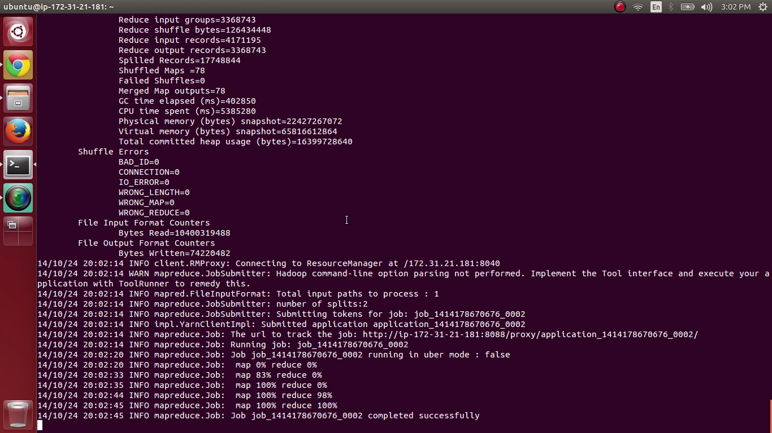

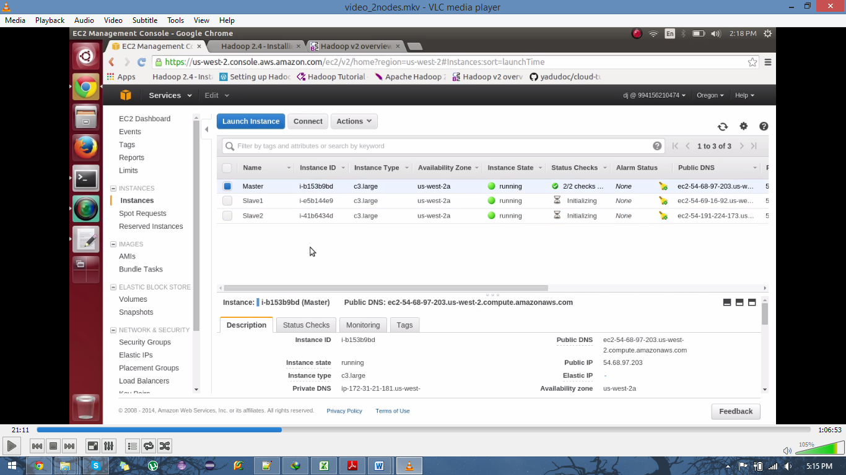

4 Nodes: 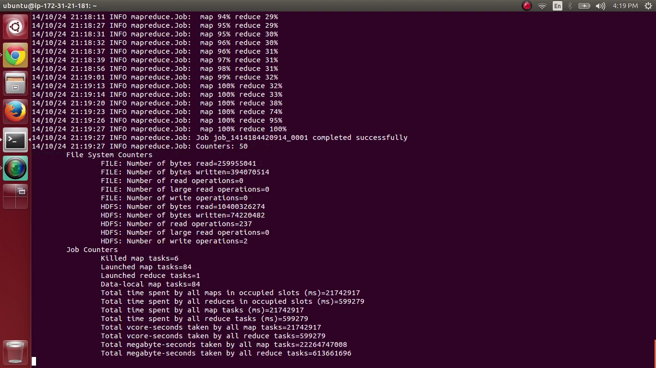

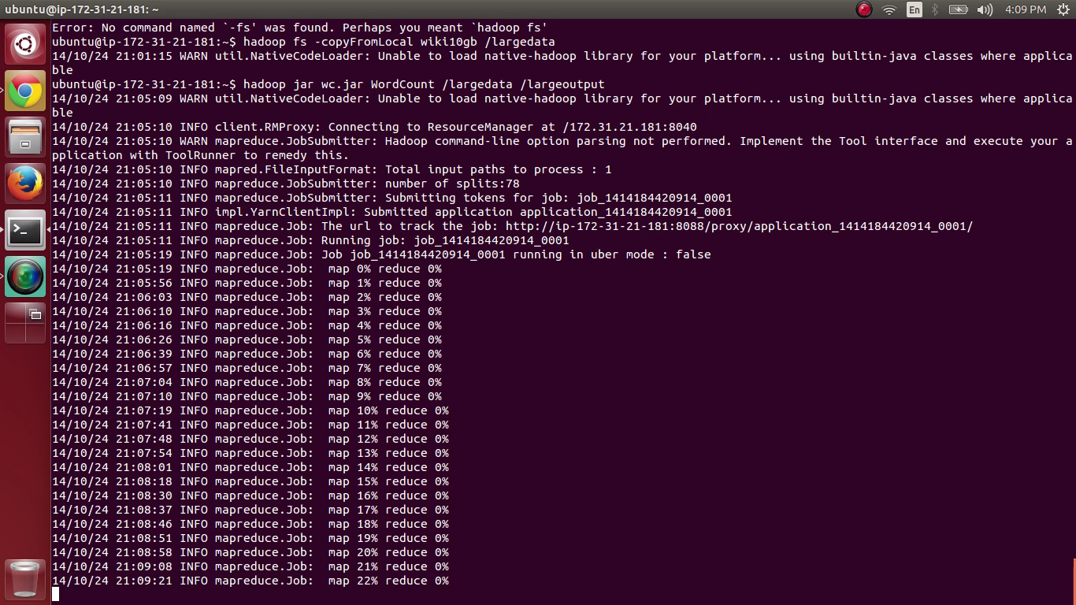

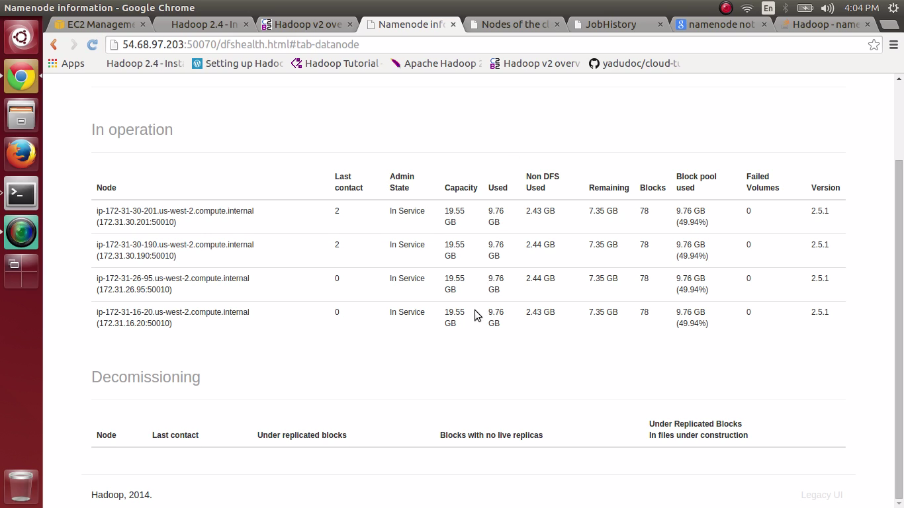

6 nodes: 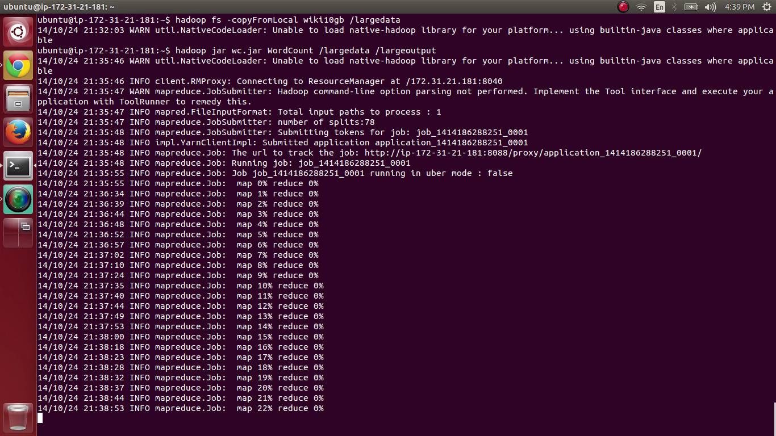

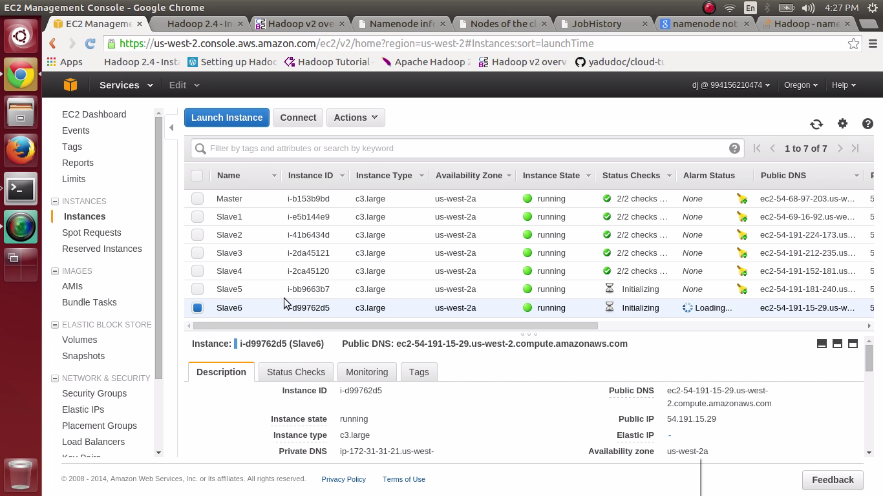

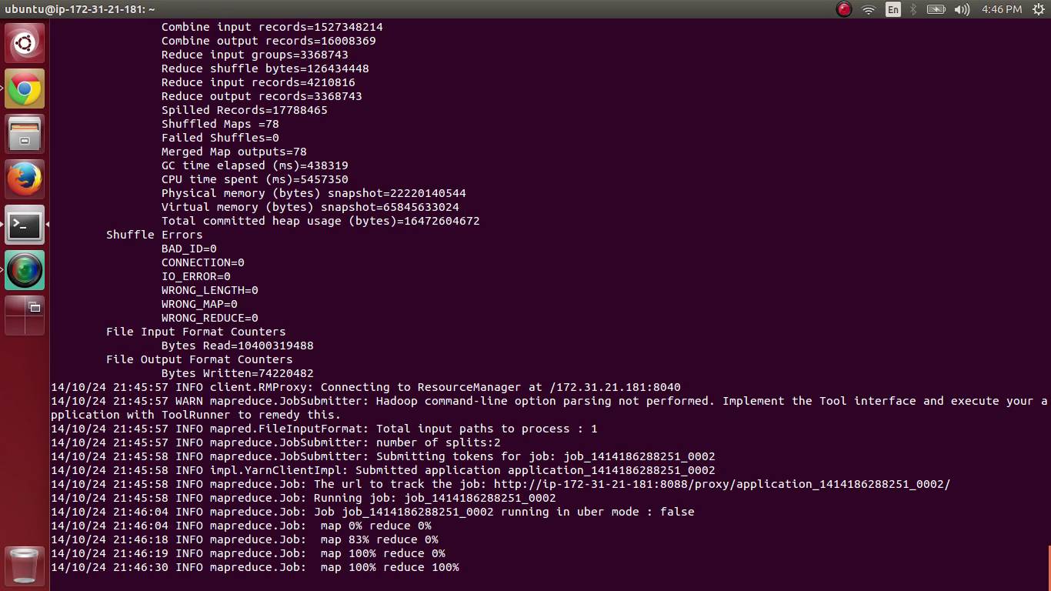

8 Nodes:

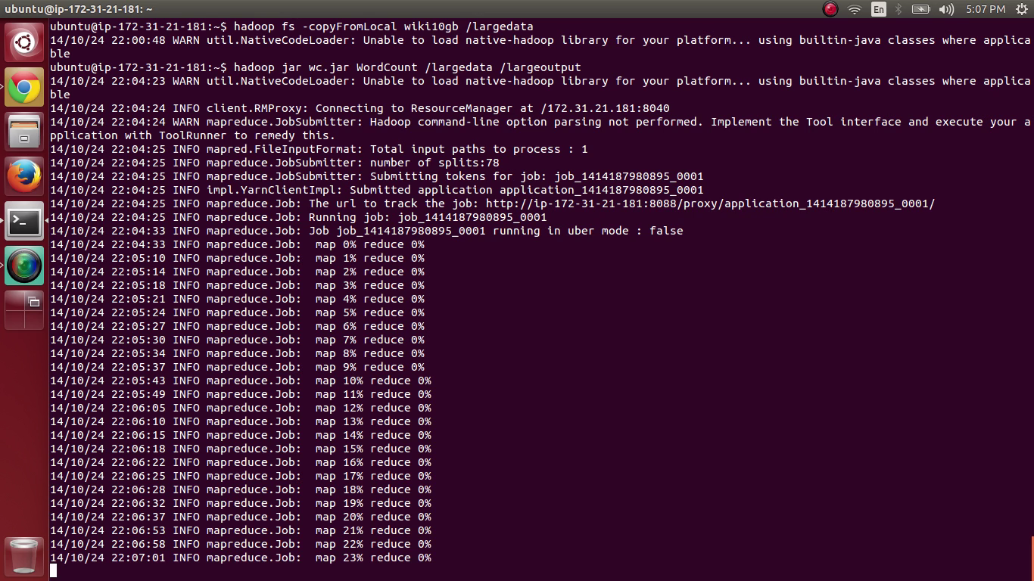

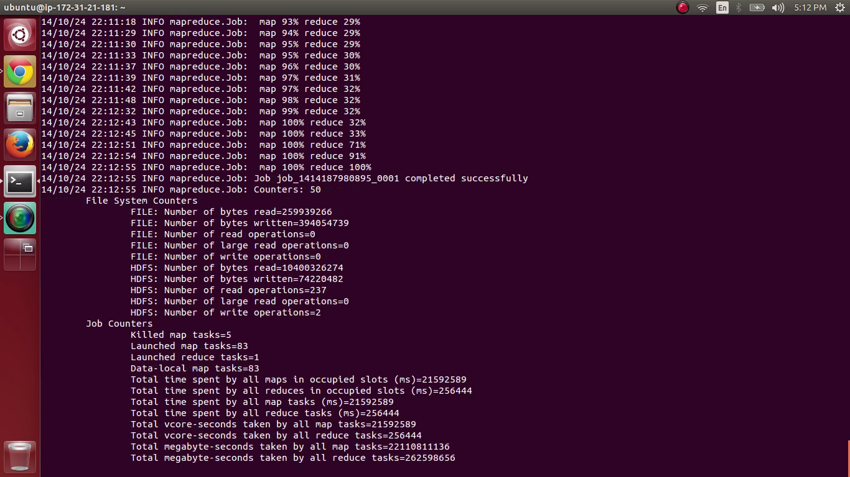

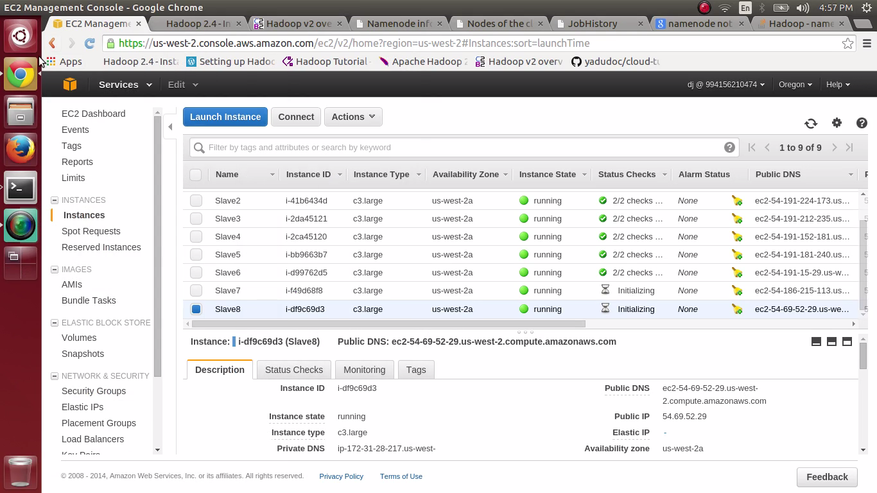

16 nodes: 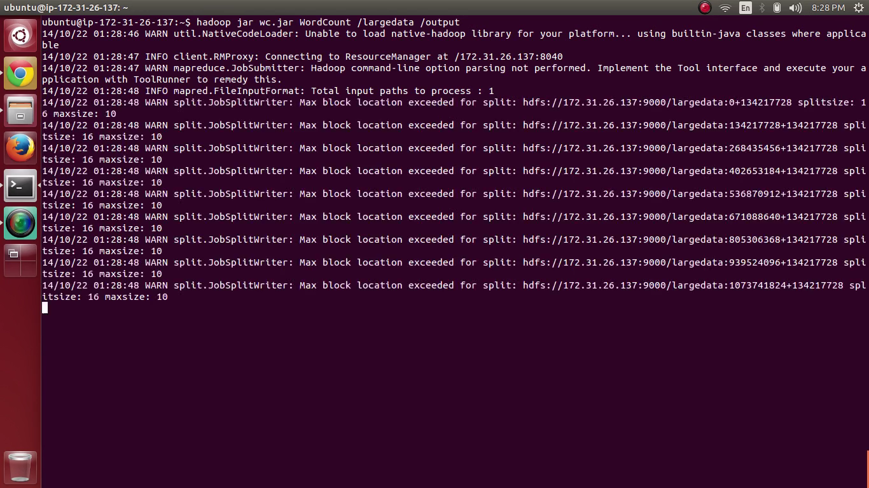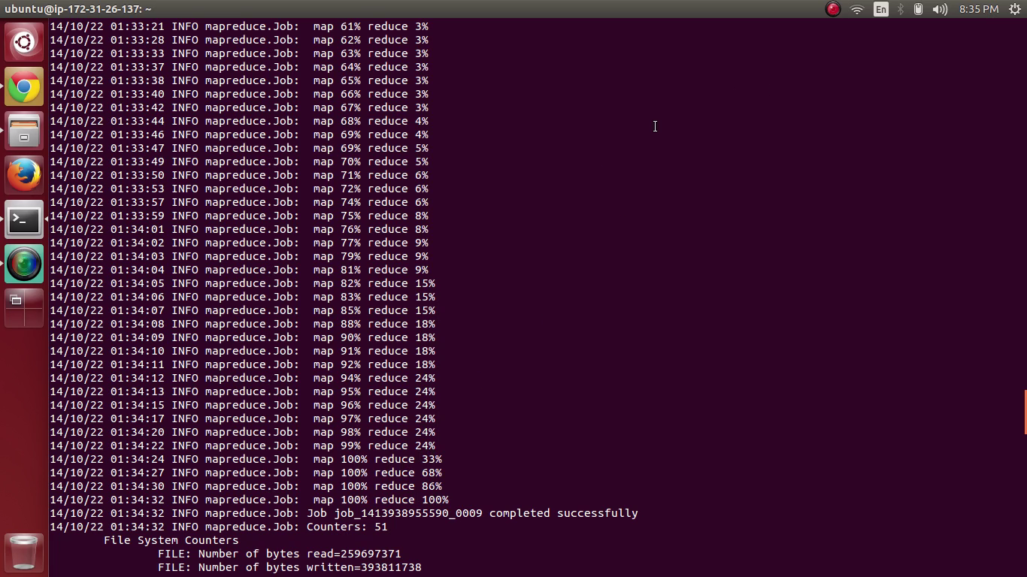

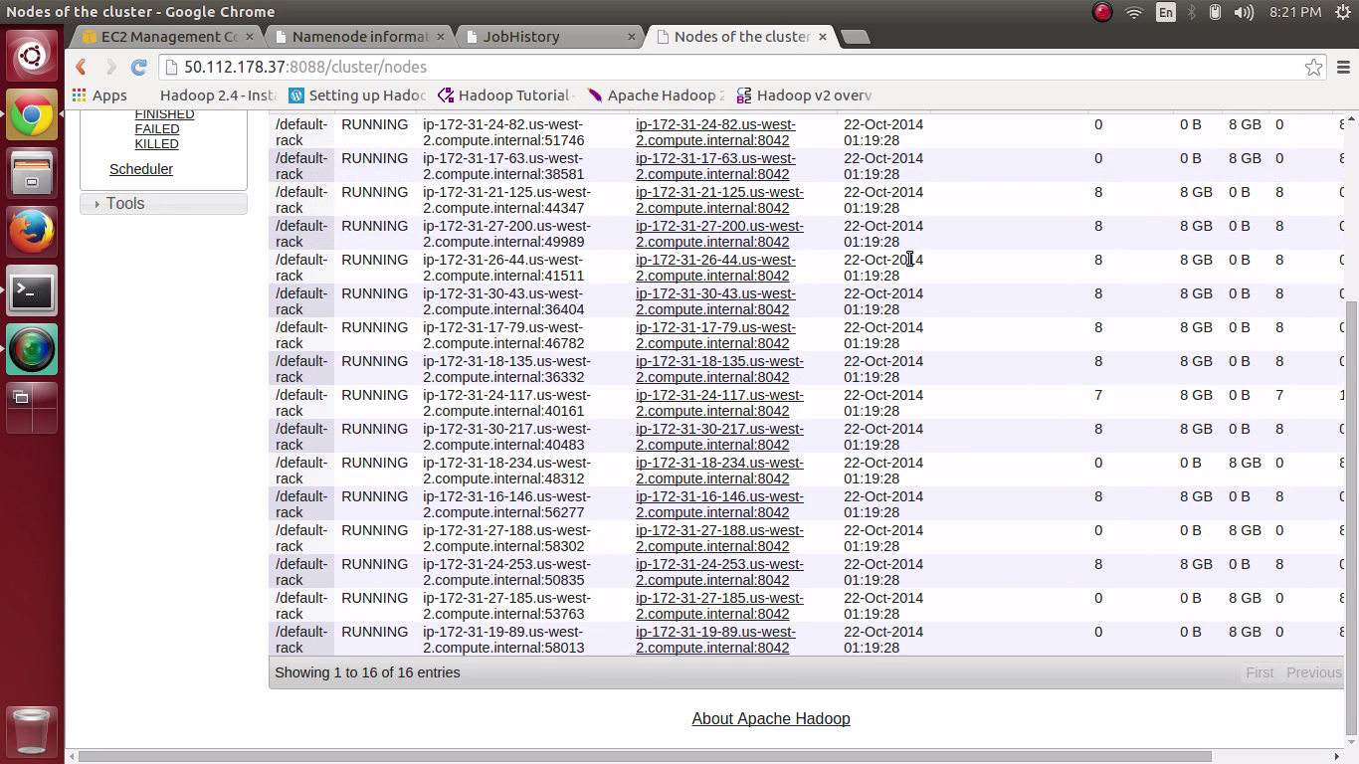

Number of nodes and the speed up time:

Base :1 Node

|  |  |  |  |
| --- | --- | --- | --- |
| Nodes | Execution time in seconds | Execution time for 1 Node | Speed Up |
| 1 | 2950 | 2950 | 1 |
| 2 | 1338 | 2950 | 2.204783259 |
| 4 | 850.8 | 2950 | 3.467324871 |
| 6 | 625.8 | 2950 | 4.713966123 |
| 8 | 498 | 2950 | 5.923694779 |
| 16 | 327.6 | 2950 | 9.004884005 |

Number of nodes and the speed up time:

Base : 8 Node

|  |  |  |  |
| --- | --- | --- | --- |
| Nodes | Execution time in seconds | Execution time for 8 Node | Speed Up |
| 1 | 2950 | 498 | 0.168813559 |
| 2 | 1338 | 498 | 0.372197309 |
| 4 | 850.8 | 498 | 0.585331453 |
| 6 | 625.8 | 498 | 0.7957814 |
| 8 | 498 | 498 | 1 |
| 16 | 327.6 | 498 | 1.52014652 |

Java 1 Thread Baseline:

|  |  |  |  |
| --- | --- | --- | --- |
| Nodes | Execution time in seconds | Execution time for 1 Thread java | Speed Up |
| 1 | 2950 | 654.552 | 0.221882034 |
| 2 | 1338 | 654.552 | 0.489201794 |
| 4 | 850.8 | 654.552 | 0.769337094 |
| 8 | 625.8 | 654.552 | 1.045944391 |
| 16 | 498 | 654.552 | 1.314361446 |

**10GB DATASET ON c3.large instance(Sorted word count without frequency based on the ASCII) :**

|  |  |
| --- | --- |
| Word Count | Execution time in seconds |
| 1 | 2841 |
| 16 | 396 |

Best Performance is achieved at 16 nodes for both types .

**SWIFT INSTALLATION:**

**Steps to get you IAM access keys:**

1. Go to the IAM console.
2. From the navigation menu, click Users.
3. Select your IAM user name, or create a new one.
4. Click User Actions, and then click Manage Access Keys.
5. Click Create Access Key.
6. Click Download Credentials, and store the keys (a .csv file) in a secure location.

##### Create a Keypair to ssh to the ec2 instances:

1. Open the Amazon EC2 console .
2. In the top navigation bar, in the region selector, click **US West (Oregon)**.
3. In the left navigation pane, under Network and Security, click Key Pairs.
4. Click Create Key Pair. Type mykeypair in the new Key pair name box.
5. Download the private key file, which is named mykeypair.pem, and keep it in a safe place. You will need it to access any instances that you launch with this key pair.

Launch an EC2 instance with AMI as Ubuntu Server 14.04 LTS (HVM).

Do shh-add mykey.pem. Then connect to the instance by using ssh –i @ubuntu:ipaddress

Then do a scp to send mykeypair.pem and credentials to the instance location.

Install the following:

1. sudo apt-get install -y python python-pip git
2. sudo pip install apache-libcloud
3. sudo apt-get install default-java
4. git clone <https://github.com/yadudoc/cloud-tutorials.git>
5. cd cloud-tutorials/ec2

Now configure the configs file to the following shown in the screen shot:

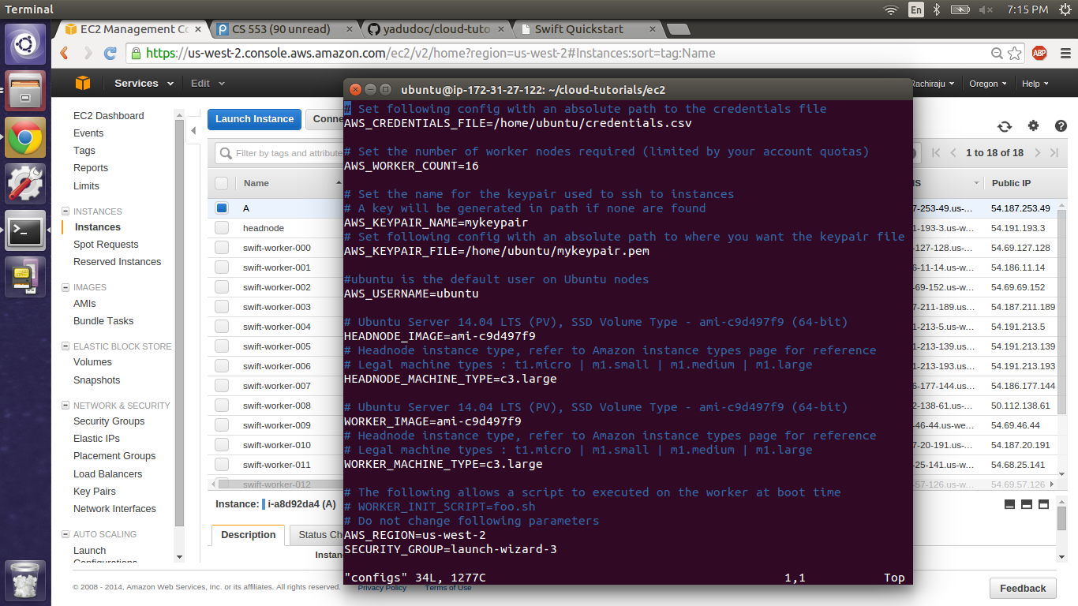

Now navigate to ec2 directory and do a source setup.sh.

To see if all the 16 workers are launched check by using list_resources.

This will give the following:

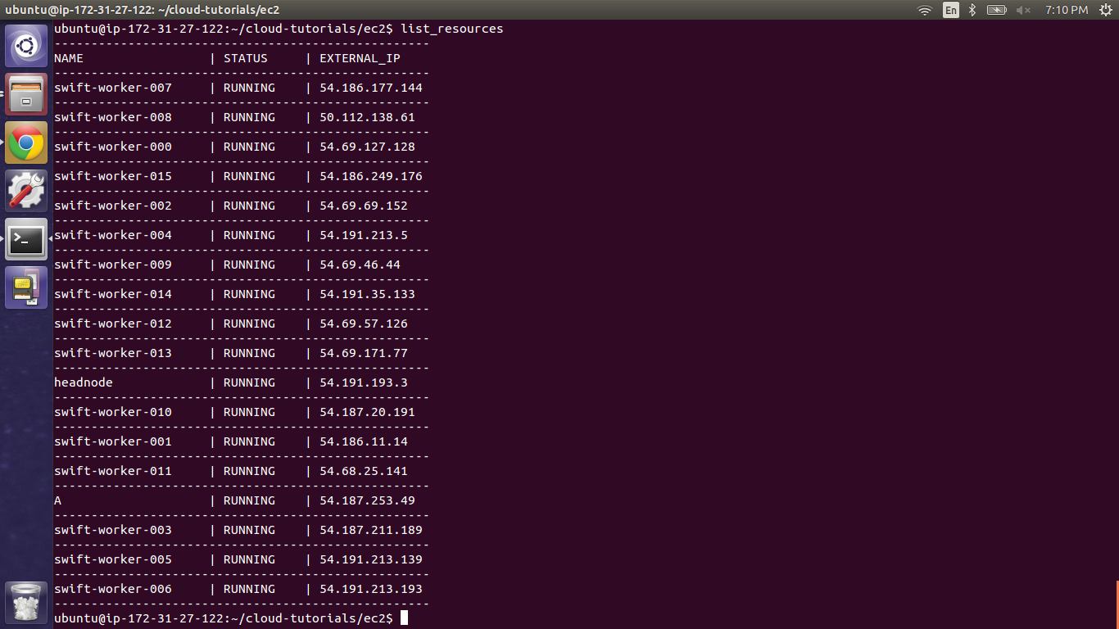

Connect to the headnode by using the “connect headnode” command.

Java and Swift Version:

To see the java version: java –version

To see the swift version: swift –version

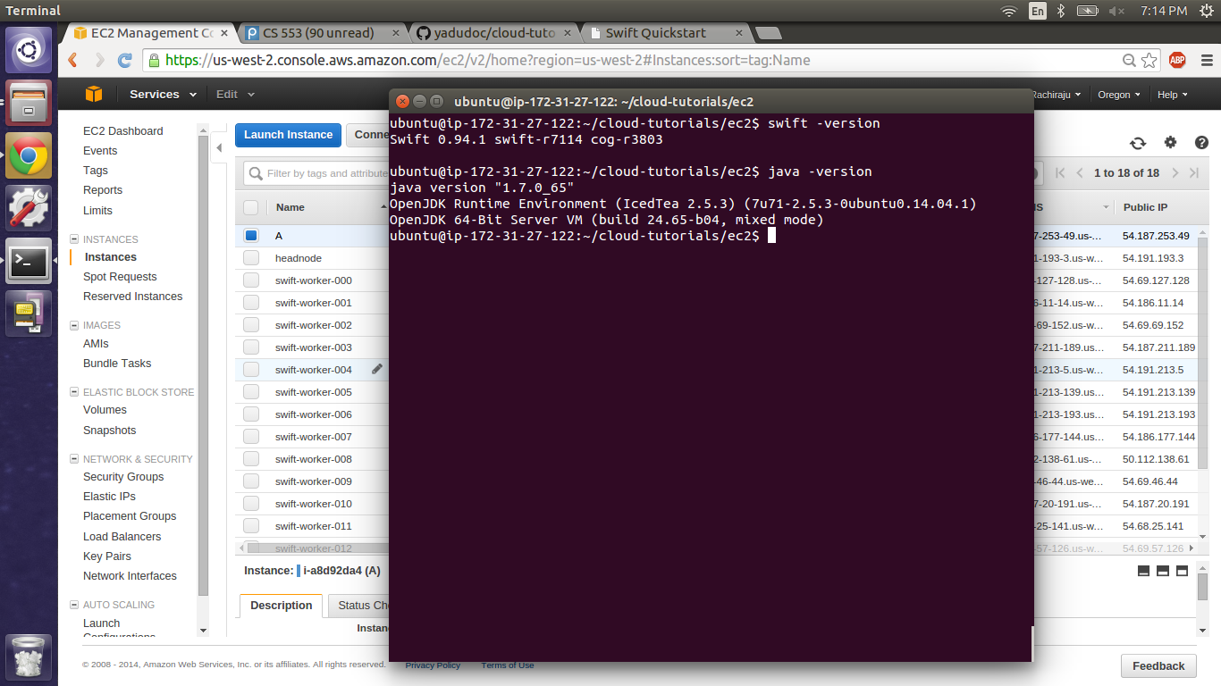

Head node and 1 Worker:

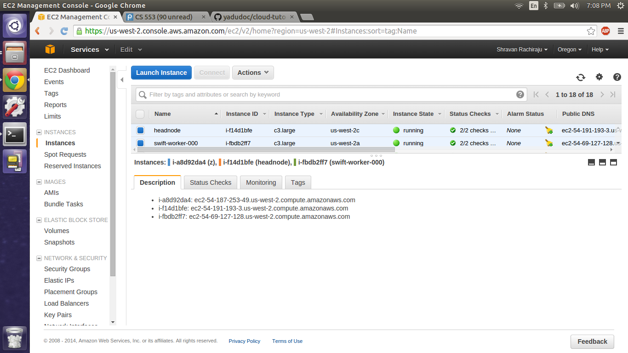

Head Node and 16 Workers:

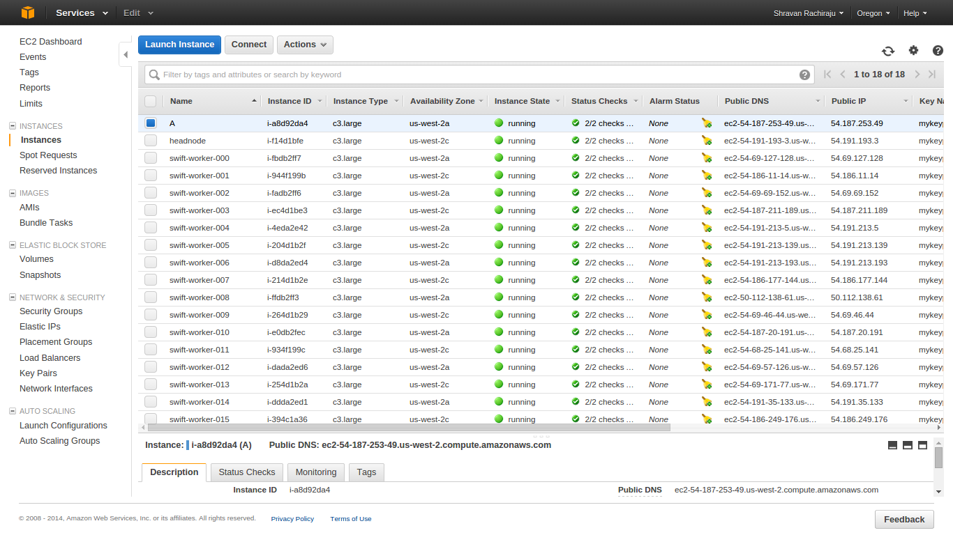

**Swift Word Count:**

**SYSTEM CONFIGURATION:**

VERSION : Swift 0.94.1

INSTANCE TYPE : c3. Large UBUNTU

RAM : 3.75 GB

NO. OF CORES : 2 virtual cores

STORAGE : 32 GB

**Methodology:**

1. Install Swift on 17 nodes (including the POSIX layer over S3 via FUSE, as Swift expects a shared POSIX filesystem between all the compute nodes)
2. Install the following in the node:

* Install python-pip, apache-libcloud
* git clone cloud-tutorials
* Configure and start the cluster

1. Create an Access key credentials.csv and store it in an secure location.
2. Connect to instance by ssh and save the credentials and key file in it.
3. Update the configs file.
4. Navigate to ec2 and do a source setup.sh
5. Connect to headnode.
6. Now run the program using swift wordCount.swift.
7. Make sure we have the config file present to run the main swift file.

Change the following in the configs file:

AWS_CREDENTIALS_FILE /home/Ubuntu/credentials.csv

AWS_WORKER_COUNT Worker count is 17

AWS_KEYPAIR_NAME mykeypair.pem

AWS_KEYPAIR_FILE /home/Ubuntu/cs553w.pem

HEADNODE_MACHINE_TYPE c3.large

WORKER_MACHINE_TYPE c3.large

**Execution results:**

|  |  |  |  |
| --- | --- | --- | --- |
| Nodes | Execution time in seconds | Execution time for 1 Node | Speed Up |
| 1 | 3687.5 | 3687.5 | 1 |
| 2 | 1672 | 3687.5 | 2.205442584 |
| 4 | 1061 | 3687.5 | 3.475494816 |
| 8 | 622.5 | 3687.5 | 5.923694779 |
| 16 | 409.2 | 3687.5 | 9.011485826 |

**GRAPH**

From the data available in the above table, a graph is plotted between number of nodes and execution time.

**GRAPH :**

Using the information from the table above a graph is plotted between number of nodes and speed up time. The baseline of this graph is value obtained at node 1.

Best Performance is obtained at 16 nodes.

Java 1 Thread baseline:

|  |  |  |  |
| --- | --- | --- | --- |
| Nodes | Execution time in seconds | Execution time for 1 Thread java | Speed Up |
| 1 | 3687.5 | 654.552 | 0.177505627 |
| 2 | 1672 | 654.552 | 0.391478469 |
| 4 | 1061 | 654.552 | 0.616919887 |
| 8 | 622.5 | 654.552 | 1.051489157 |
| 16 | 409.2 | 654.552 | 1.599589443 |

Graph:

Sorting in SWIFT:

|  |  |
| --- | --- |
| Word Count | Execution time in seconds |
| 1 | 2131 |
| 16 | 372 |

Best Performance is obtained at 16 nodes

Performance:

|  |  |  |
| --- | --- | --- |
| PLATFORM | NUMBER OF NODES | EXECUTION TIME in seconds  Word Count |
| JAVA | 1 | 654.552 |
| HADOOP | 1 | 2950 |
| SWIFT | 1 | 3687 |
| JAVA | 1 | 654.552 |
| HADOOP | 16 | 327.6 |
| SWIFT | 16 | 409 |

Out of all the three **HADOOP** is said to give the best performance.

From the above table we can say that best performance at 16 nodes is offered by HADOOP and at 1 node is offered by JAVA. Compared to 1 node execution time of JAVA execution time of 16 nodes of SWIFT and HADOOP is faster. Let it be 100 nodes or 1000 nodes it doesn’t make any difference as you scale from 16 nodes to higher because the execution time stays constant as there is resource saturation.

While Considering sorting we can see that swift gives the best performance. It gives almost 1/4th times that of hadoop. So while considering sorting we can say that SWIFT has the best performance.

**MPI Sort:**

**Configuration:**

VERSION : MPI 3.1.3

INSTANCE TYPE : c3. Large UBUNTU

RAM : 3.75 GB

NO. OF CORES : 2 virtual cores

STORAGE : 32 GB

**Methodology:**

MPI INSTALL VERSION: mpich3.1.3

1.install mpich3.1.3 and configure it with command ./configure disable --fortran

2. build $make

after the installation of mpich3.1.3 on the local node

3. run MPIsort.cpp using

mpicc MPIsort.cpp -o MPITsort

after compilation the resulting file is an executable file MPIsort

4. mpirun -np 2 /home/ubuntu/MPIsort wiki10gb.txt

mpirun executes the executable file with 2 processes sorting the wiki10gb.txt file.

Running MPI ON AMAZON EC2

run the below commands

sudo apt-get install pythonsetuptools

sudo apt-get install python-pip

sudo apt-get update

sudo easy_install -upgrade pip

sudo easy_install StarCluster0.95.5

and install pycrypto-2.6.1

after installing Starcluster0.95.5

configure starcluster in

./starcluster/config

and after configuring the start cluster is installed

now start the cluster on 16 nodes.